

**JOMO KENYATTA UNIVERSITY OF AGRICULTURE AND TECHNOLOGY**

**SCHOOL OF ELECTRICAL, ELECTRONIC AND INFORMATION ENGINEERING**

**DEPARTMENT OF ELECTRICAL AND ELECTRONIC ENGINEERING**

**BSC ELECTRONIC AND COMPUTER ENGINEERING**

**FINAL YEAR PROJECT REPORT**

**PROJECT TITLE:**

**SMART PERSONAL PROTECTIVE EQUIPMENT FOR CONSTRUCTION WORKERS**

**SUBMITTED BY:**

**NDERE MAGDALINE MOKEIRA – ENE212-0075/2017**

**PROJECT SUPERVISOR: MR. MANEGENE**

*A Final Year Project Proposal submitted to the Department of Electrical and Electronic Engineering in partial fulfillment of the requirements for the award of a Bachelor of Science Degree in Electronic and Computer Engineering.*

**DECEMBER 2022**

DECLARATION

This project proposal is my original work and to the best of my knowledge, has never been presented to Jomo Kenyatta University of Agriculture and Technology or any other institution for the award of a degree or diploma.

**NAME:** MAGDALINE MOKEIRA NDERE **REG. NO.:** ENE212-0075/2017

**SIGNATURE………………………………………… DATE ………………………………**

**SUPERVISOR CONFIRMATION:**

This project proposal has been submitted to the Department of Electrical and Electronic Engineering, Jomo Kenyatta University of Agriculture and Technology, with my approval as the supervisor:

**NAME:** MR. MANEGENE

**SIGNATURE………………………………………… DATE ………………………………**

**TABLE OF CONTENTS**

[DECLARATION i](#_Toc119591045)

[TABLE OF CONTENTS ii](#_Toc119591046)

[LIST OF FIGURES v](#_Toc119591047)

[LIST OF TABLES vii](#_Toc119591048)

[LIST OF ABBREVIATIONS viii](#_Toc119591049)

[ABSTRACT ix](#_Toc119591050)

[CHAPTER ONE 1](#_Toc119591051)

[1. INTRODUCTION 1](#_Toc119591052)

[1.1. BACKGROUND STUDY 1](#_Toc119591053)

[1.2. PROBLEM STATEMENT 3](#_Toc119591054)

[1.3. PROBLEM JUSTIFICATION 4](#_Toc119591055)

[1.4. OBJECTIVES 4](#_Toc119591056)

[1.4.1. Main Objective 4](#_Toc119591057)

[1.4.2. Specific objectives 4](#_Toc119591058)

[1.5. SCOPE OF STUDY 5](#_Toc119591059)

[CHAPTER TWO 6](#_Toc119591060)

[2. LITERATURE REVIEW 6](#_Toc119591061)

[2.1. INTRODUCTION 6](#_Toc119591062)

[2.2. WIRELESS TECHNOLOGIES 6](#_Toc119591063)

[2.2.1. Radio Frequency Transmission 7](#_Toc119591064)

[2.2.2. Infrared Transmission 7](#_Toc119591065)

[2.2.3. Microwave Transmission 8](#_Toc119591066)

[2.2.4. Lightwave Transmission 9](#_Toc119591067)

[2.2.5. Radio 10](#_Toc119591068)

[2.2.6. Cellular 10](#_Toc119591069)

[2.2.7. Satellite 11](#_Toc119591070)

[2.2.8. Wi-Fi 11](#_Toc119591071)

[2.2.9. Bluetooth Technology 13](#_Toc119591072)

[2.2.10. ZigBee 13](#_Toc119591073)

[2.2.11. WiMAX 14](#_Toc119591074)

[2.3. MICROCONTROLLERS 15](#_Toc119591075)

[2.3.1. Arduino Mega 2560 15](#_Toc119591076)

[2.3.2. Raspberry Pi Development Board 16](#_Toc119591077)

[2.3.3. The BeagleBone Black Development Board 17](#_Toc119591078)

[2.3.4. AdaFruit Flora Development Board 18](#_Toc119591079)

[2.3.5. NodeMCU ESP8266 Based Development Board 19](#_Toc119591080)

[2.3.6. Teensy 4.0 20](#_Toc119591081)

[2.3.7. The BBC micro: bit V2 22](#_Toc119591082)

[2.3.8. Intel Edison 23](#_Toc119591083)

[2.3.9. STM32 32-bit Arm Cortex MCUs 24](#_Toc119591084)

[2.3.10. ESP32 Microcontroller Board 25](#_Toc119591085)

[2.4. SENSORS 26](#_Toc119591086)

[2.4.1. Heartbeat Sensor 26](#_Toc119591087)

[2.4.2. Temperature sensor 28](#_Toc119591089)

[2.4.3. Accelerometer and Gyroscope Sensor 30](#_Toc119591091)

[2.4.4. GPS Module 33](#_Toc119591093)

[2.4.5. GSM/GPRS Module 34](#_Toc119591095)

[2.4.6. Force Sensor (FSR) 36](#_Toc119591097)

[2.5. CONCULUSION 39](#_Toc119591098)

[CHAPTER THREE 40](#_Toc119591099)

[3. METHODOLOGY 40](#_Toc119591100)

[3.1. PROPOSED SYSTEM 40](#_Toc119591101)

[3.2. FALL DETECTION 41](#_Toc119591102)

[3.2.1. Accelerometer Gyroscope Vector Signal Resultant (AGVeSR) 41](#_Toc119591103)

[3.2.2. Alpha Degree (∠α) 42](#_Toc119591104)

[3.2.3. Gyroscope Resultant Distance (GyroRe) 44](#_Toc119591105)

[3.3. CIRCUIT DESIGN 47](#_Toc119591106)

[3.3.1. Interfacing TMP36 Temperature Sensor with Arduino 47](#_Toc119591107)

[3.3.2. Interfacing RP-S40-ST Thin Film Pressure Sensor with Arduino 48](#_Toc119591108)

[3.3.3. Interfacing the Buzzer with Arduino 49](#_Toc119591109)

[3.3.4. Interfacing MPU6050 Accelerometer + Gryo Sensor with Arduino 50](#_Toc119591110)

[3.3.5. Interfacing MAX30100 Heart Beat Sensor with Arduino 51](#_Toc119591111)

[3.3.6. Interfacing NEO-6M GPS Module with Arduino 52](#_Toc119591112)

[3.3.7. Interfacing SIM800L GSM Module with Arduino 53](#_Toc119591113)

[3.3.8. Overall circuit diagram 54](#_Toc119591114)

[CHAPTER FOUR 55](#_Toc119591115)

[4. RESULTS AND ANALYSIS 55](#_Toc119591116)

[4.1. HARDWARE DESIGN 55](#_Toc119591117)

[4.2. SOFTWARE DESIGN ANALYSIS 56](#_Toc119591118)

[4.2.1. SIM800L GSM module output 56](#_Toc119591119)

[CHAPTER FIVE 57](#_Toc119591120)

[5. CONCULION AND RECOMMENDATIONS 57](#_Toc119591121)

[5.1. CONCLUSION 57](#_Toc119591122)

[5.2. RECOMMENDATION 57](#_Toc119591123)

[BUDGET 58](#_Toc119591124)

[PROJECT TIME PLAN 59](#_Toc119591126)

[REFERENCES 60](#_Toc119591128)

[APPENDIX 62](#_Toc119591129)

[APPENDIX 1: Interfacing TMP36 Temperature Sensor with Arduino code 62](#_Toc119591130)

[APPENDIX 2: Interfacing RP-S40-ST Thin Film Pressure Sensor with Arduino code 62](#_Toc119591131)

[APPENDIX 3: Interfacing Buzzer with Arduino code 63](#_Toc119591132)

[APPENDIX 4: Interfacing MPU6050 Accelerometer + Gyro Sensor with Arduino code 64](#_Toc119591133)

[APPENDIX 5: Interfacing MAX30100 Heart Beat Sensor with Arduino code 65](#_Toc119591134)

[APPENDIX 6: Interfacing NEO-6M GPS module with Arduino code 66](#_Toc119591135)

[APPENDIX 7: Interfacing SIM800L GSM module with Arduino code 67](#_Toc119591136)

[APPENDIX 8: Overall circuit Arduino code 68](#_Toc119591137)

LIST OF FIGURES

[Figure 2.1: MAX30100 heartbeat sensor 27](#_Toc119591138)

[Figure 2.2: TMP36 Temperature Sensor 29](#_Toc119591139)

[Figure 2.3: MPU6050 Accelerometer + Gyro 31](#_Toc119591140)

[Figure 2.4: NEO-6MV2 GPS Module 34](#_Toc119591141)

[Figure 2.5: SIM800L GSM module 35](#_Toc119591142)

[Figure 2.6: RP-S40-ST Thin Film Pressure Sensor 38](#_Toc119591143)

[Figure 3.1: Block diagram of proposed system 40](D:\\documents\\ece 5.1\\project\\MOKEIRA-FINAL PROJECT REPORT V2.docx" \l "_Toc119591144)

[Figure 3.2: Block diagram of the fall detection system 41](D:\\documents\\ece 5.1\\project\\MOKEIRA-FINAL PROJECT REPORT V2.docx" \l "_Toc119591145)

[Figure 3.3: Fall Detection Flow Chart 44](#_Toc119591146)

[Figure 3.4: After Fall Impact Flow Chart 45](D:\\documents\\ece 5.1\\project\\MOKEIRA-FINAL PROJECT REPORT V2.docx" \l "_Toc119591147)

[Figure 3.5: Physiological Parameters Flowchart 46](D:\\documents\\ece 5.1\\project\\MOKEIRA-FINAL PROJECT REPORT V2.docx" \l "_Toc119591148)

[Figure 3.6: Interfacing TMP36 Temperature Sensor with Arduino 47](#_Toc119591149)

[Figure 3.7: Interfacing RP-S40-ST Thin Film Pressure Sensor with Arduino 48](#_Toc119591150)

[Figure 3.8: Interfacing the Buzzer with Arduino 49](#_Toc119591151)

[Figure 3.9: Interfacing MPU6050 Accelerometer + Gryo Sensor with Arduino 50](#_Toc119591152)

[Figure 3.10: Interfacing MAX30100 Heart Beat Sensor with Arduino 51](#_Toc119591153)

[Figure 3.11: Interfacing NEO-6M GPS Module with Arduino 52](#_Toc119591154)

[Figure 3.12: Interfacing SIM800L GSM Module with Arduino 53](#_Toc119591155)

[Figure 3.13: Overall circuit diagram 54](#_Toc119591156)

[Figure 4.1: An external wearable device 55](#_Toc119591157)

[Figure 4.2: A smart hardhat 55](#_Toc119591158)

LIST OF TABLES

[Table 2.1:Pin configuration of MAX30100 heartbeat sensor 27](#_Toc118038100)

[Table 2.2: Pin configuration of TMP36 Temperature Sensor 30](#_Toc118038101)

[Table 2.3: Pin configuration of MPU6050 Accelerometer + Gyro 32](#_Toc118038102)

[Table 2.4: Pin configuration of NEO-6MV2 GPS Module 34](#_Toc118038103)

[Table 2.5: Pin configuration of SIM800L GSM module 35](#_Toc118038104)

[Table 5.1: Budget 48](#_Toc118038105)

[Table 6.1: Work Plan 49](#_Toc118038106)

LIST OF ABBREVIATIONS

|  |  |
| --- | --- |
| 3D | 3-Dimensional |
| ADC | Analog Digital Converter |
| AP | Access Point |
| BLE | Bluetooth Low Energy |
| CPU | Central Processing Unit |
| DSL | Digital Subscriber Line |
| EMF | Electric and Magnetic Field |
| FPU | Floating point Unit |
| GPIO | General-Purpose Input/Output |
| GPRS | General Packet Radio Service |
| GPS | Global Positioning System |
| GSM | Global System for Mobile Communication |
| I/O | Input/Output |
| IC | Integrated Circuit |
| ICSP | In-Circuit Serial Programmer |
| IDE | Integrated Development Environment |
| IOT | Internet of Things |
| IR | Infrared |
| LAN | Local Area Network |
| LCD | Liquid Crystal Display |
| LED | Light Emitting Diode |
| MCU | Microcontroller Unit |
| PCB | Printed Circuit Board |
| PDA | Personal Digital Assistant |
| PoS | Point of Sale |
| PPE | Personal Protective Equipment |
| PWM | Pulse Width Modulation |
| RAM | Random Access Memory |
| RF | Radio Frequency |
| RTC | Real-Time Clock |
| SD | Secure Digital |
| SMS | Short Message Service |
| SPO2 | Oxygen saturation |
| TTL | Transistor- Transistor Logic |
| USB | Universal Serial Bus |
| Wi-Fi | Wireless Fidelity |
| WiMAX | Worldwide Interoperability for Microwave Access |
| MEMS | Micro Electro Mechanical Systems |

ABSTRACT

Despite various safety inspections carried out over the years to ensure compliance with regulations and maintain acceptable and safe working conditions, construction is still among the most dangerous industries responsible for a large portion of the total worker fatalities. A construction worker has a chance of 1-in-200 of dying on the job during a 45-year career, mainly due to fires, falls, and being struck or caught-in/between objects. Therefore, a preventative measure has to be introduced in the personal protective equipment.

This project seeks to prevent such fatalities from happening by alerting a construction worker in case of falls, both low/ high heartrate and temperature rates, alerting the site managers and emergency health team also of the same while also providing the specific location of the worker.

The smart PPE will be fitted with temperature and heartbeat sensors to check if the worker is in healthy conditions to perform tasks. A force sensor to detect any impact force experienced during a fall by a worker. A gyroscope and accelerometer sensor to detect the worker’s inclination angle and acceleration in case of a fall and automatically alert the emergency services if the impact experienced is severe. The worker shall be alerted via a buzzer. The devices that will be used include Arduino microcontroller, accelerometer sensor, gyroscope sensor, force sensor, heartbeat sensor, temperature sensor, GPS and GSM module and a buzzer.

CHAPTER ONE

# INTRODUCTION

## BACKGROUND STUDY

Due to their design, construction projects and operations in industrial settings are distinguished by the high risk of hazard exposure. The primary reasons as to why accidents happen at industrial sites are linked to the distinctive nature of the industry, how humans behave, technical elements, hazardous working conditions, and inadequate safety management. All these elements lead to working methods and practices that are dangerous. Accidents experienced in construction sites are not unique to developed or developing nations but are rather experienced globally, though at different degrees in either region. There is an astonishing difference in the accident rates between countries that are developed and those that are developing.

Every year, approximately 60,000 fatalities arise in industrial settings across the globe, and this means that every nine minutes, an industrial setting fatality occurs. In Finland, the construction industry contributed to 7.685% of all non-fatal work injuries. In America alone, there are more than 900 fatal accidents that are reported in construction work places annually with non-fatal injuries exceeding 200,000. The Kenyan sector recorded 40 fatalities and 383 non-fatality cases between 2010 and 2011.Despite the importance leveraged on safety compliance, the Kenyan sector has shown a trend that shows poor adoption of safety practices and safety compliance among contractor firms, more so, small contractor firms. Safety observance with health and safety necessities is lacking. This is because Kenyan employers rarely comply with the law, and this leaves their workers exposed to unhealthy working conditions [1].

Should the Smart PPE device be expanded upon and brought to market, it would provide a myriad of benefits to many parties involved in the industry. Workers would experience a safer work environment, and avoid high amounts of physical, emotional, and financial hardship associated with injury, while employers will avoid many direct and indirect costs associated with worker injuries. Increased worker production and safety will contribute to a decrease in indirect costs to the employers including:

* Wages paid to injured workers during absence.
* Time lost through reduced or light duty staff.
* Administrative time spent by supervisors following injuries.
* Employee training and replacement costs.
* Lost productivity related to new employee training and accommodation of injured employees.

Competition in this market sector includes the major PPE Manufacturing Companies, 3M

Company, MSA Safety Inc., and Honeywell International Inc. The global personal protective equipment market size was valued at USD 77.36 billion in 2020 [2]. We also face competition from smaller startup companies that produce innovative biometric monitoring protective equipment. Some existing products already on the market include the Life Beam’s Smart Bicycle Helmet, and Smart Athletic Hat which measure heart rate via an optical sensor, cadence, and calorie consumption during exercise. The measurement signals are sent wirelessly to the user’s smartphone or fitness watch via Bluetooth [3]. Riddell’s InSite Impact Response Football Helmet is fitted with a series of sensors and electrical components to evaluate the impacts sustained while on the field. In addition to monitoring the force, location, and intensity of the impacts, the helmet transmits alerts wirelessly to a monitor if impact thresholds are exceeded [4]. Schutt’s Smart Football Helmet uses a thermistor to monitor the player’s body temperature and an onboard radio transmits temperature readings in real time to a personal digital assistant (PDA) held on the sidelines [5]. Additionally, a new prototype hard hat product is being developed by Laing O’Rourke that combines a sensor array into an insert for retrofitting into an existing hard hat. This prototype monitors the temperature and heart rate of the worker, GPS location, and external temperature and humidity of the work environment. It utilizes a vibratory and auditory alert system for the wearer, and email or text message alerts can be sent to other parties [6]. Also, an existing product is the SolePower Self Powered Smart Boot, that can be powered solely by a person moving.  From helping the military charge a battery while on their feet to reducing accidents by keeping track of workers on job sites [7]. Several of the designs utilize wireless transceivers that display alarms in response to events monitored by protective gear via the use of biometric sensors.

This device differentiates from the competition by combining the key biometric sensors that can indicate danger to a worker (body temperature, heart rate, and concussive force) into one product, and transmitting that information through cellular data to a site supervisor using a Global System for Mobile Communication (GSM) board. This method of signal transmission is preferred over Bluetooth due to the long range of signal transmission capable while using GSM. Site supervisors will not need to carry around additional electronic alert equipment, and they will not need to be within wireless Bluetooth range to receive notification that their workers’ health and safety is in danger. The text message alerts include the worker ID, time, and the biometric threshold that has been exceeded. Additionally, there is an immediate feedback alert to the worker via a microphone on the hat brim, which indicates if a threshold has been exceeded. A location sensor will also track the worker’s movement and a gyroscope to detect falls.

## PROBLEM STATEMENT

Industrial site safety is one of the biggest challenges that contractors face. Every contractor needs to implement stringent safety rules for the job site to protect employees and, of course, have sufficient [contractor’s insurance](https://affordablecontractorsinsurance.com/contractors-insurance/) to take care of any liabilities. The major problems are discussed as follows [8]:

When you consider the diverse range of activities going on at an industrial site at any one time it seems hardly surprising slips, trips, and falls happen on an almost daily basis. Industrial sites are a mish mash of holes in the ground, buildings at various stages of completion, scaffolding, stored materials and equipment: you really do need eyes in the back of your head at times. This device will be able to detect the worker’s inclination angle and warm him/her a fall is impending.

Every year excavations and trenches collapse, bury and seriously injure people working in them – precautions need to be planned before the work starts. The risk of an unintended collapse is generally more associated with demolition works or when a partially completed building or scaffolding collapses, but still accounts for a percentage of fatalities each year. Therefore, this device will be able to detect and measure the acceleration of any body or object in its instantaneous rest frame and alert the worker about that. In case of a collapse, the worker shall also be easily tracked and hence increasing the chances of survival.

Industrial sites are a throng of activity and kick up a lot of dust-an often invisible, fine, toxic mixture of hazardous materials and fibers that can damage the lungs, leading to diseases such as chronic obstructive pulmonary, asthma and silicosis. Simply issuing PPE is not enough…employers have a duty to ensure protective equipment is actually used. Failure to do so could render an employee to disciplinary action and in hot water with the health and safety executive. Therefore, this device will have some biometric sensors capable of determining one’s state of body hence third-party injuries and accidents can be reduced through this.

## PROBLEM JUSTIFICATION

Technology is continually undergoing a constituent development caused by the appearance of billions new interconnected “things” and their entrenchment in our daily lives. One of the underlying versatile technologies, namely wearables, is able to capture rich contextual information produced by such devices and use it to deliver a legitimately personalized experience.  In the near future, wearable technologies are expected to become an indispensable part of our daily life. This wearable technology should be exploited to assist workers in industrial settings experience a safer work environment, and avoid high amounts of physical, emotional, and financial hardship associated with injury, while employers will avoid many direct and indirect costs associated with worker injuries.

This project will provide a monitoring system that will allow both worker and supervisor to view the worker’s body temperature, heartrate and concussive force experienced in real time. At the same time, tracking the worker’s location, detecting falls. By using a heart pulse sensor, thermocouple, accelerometer, gyroscope, GPS and GSM modules all connected to an Arduino microcontroller, the system collects data and transmits it wirelessly using a communication module to the parties involved so as informed decisions can be made.

## OBJECTIVES

### Main Objective

To design and develop a smart PPE for workers in industrial settings.

### Specific objectives

1. To design a PPE that detects body temperature, heart rate, impact forces, falls and location of the worker.
2. To design a wireless communication system that transmits information to a remote location
3. To design an alerting system that processes and evaluates set threshold biometric values and sends alert
4. To implement and test performance of the designed system.

## SCOPE OF STUDY

This project’s scope utilized a heart rate sensor to detect heart pulses, an infrared thermometer to measure the temperature, an accelerometer sensor to measure the impact in 3D, a gyroscope to detect a person’s inclination angle, a GPS module that gives the location of a given worker and a GSM module that will aid in communication. Overall, the wireless communication will alert the given parties (worker, supervisor and the emergency health care team) in case any values detected by the sensors go above or below the set threshold values. This project will not involve creating a web-based user interface.

This project is limited to use of 3 sensors and a wireless communication system. It has an SMS based interface.

CHAPTER TWO

# LITERATURE REVIEW

## **INTRODUCTION**

Construction sites are inherently hazardous environments. To mitigate job-related risks, however, companies’ industry wide are increasingly turning to advanced safety technologies. The technology that’s on the rise: wearables. Smart, wearable technology on construction sites can increase productivity, prevent injury and keep workers aware of situational hazards and their health.

Head to toe wearables are the future of jobsite safety. Smart hard hats, watches, monitors and boots, augmented reality glasses, exoskeletons and wearable sensors not only enhance workplace safety, but also benefit businesses by providing critical lines of communication and actionable data collection. Of the potential solutions construction firms can implement, wearable devices offer a high level of user functionality and are among the most insightful. Equipped with sensors, GPS, heart-rate monitors, activity trackers, pressure, fall and gas detection, wearables can track a plethora of worker health and safety metrics. This data can in turn be used by companies to better address safety concerns across jobsites, before accidents or injuries occur.

Wearable technology is also transforming boots, helmets and safety glasses into powerful, data-collecting and sharing devices. Pressure and location sensors placed in footwear can detect falls and shocks, track worker location and alert help. Fitted with sensor bands, hard hats become an even more critical piece of safety equipment — tracking vital signs to detect fatigue and alerting workers and equipment operators of potential collisions when paired with heavy machinery sensors. Smart safety glasses are providing workers with live-field data and updates on hazardous materials, leading edges and safety protocols.

## **WIRELESS TECHNOLOGIES**

Wireless communication plays a significant role in day-to-day life. Besides communication, wireless technology has become an integral part of our daily activities. The transmission of data or information from one place to another wirelessly is referred to as wireless communication. This provides an exchange of data without any conductor through RF and radio signals. The information is transmitted across the devices over some meters to hundreds of kilometers through well-defined channels [9].

Different types of signals are used in communication between the devices for wireless transmission of data. The following are the different electromagnetic signals used depending on their wavelength and frequency.

### Radio Frequency Transmission

Radiofrequency is a form of electromagnetic transmission used in wireless communication. RF signals are easily generated, ranging 3kHz to 300GHz. These are used in wireless communication because of their property to penetrate through objects and travel long distances.

The radio system is one type of wireless data transmission, and it is a wireless media that transfers data by carrying electromagnetic waves with low frequencies to distant locations through an electrical conductor and an antenna. Ham radio enthusiasts share information and serve as emergency communication aids during disasters with their powerful amateur broadcasting equipment and can even communicate digital data over the radio spectrum [10].

Radio communication depends on the wavelength, transmitter power, receiver quality, type, size, and height of the antenna.

**Drawbacks**

1. These are frequency-dependent.
2. These have a relatively low bandwidth for data transmission.

### Infrared Transmission

Infrared radiations are electromagnetic radiations with longer wavelengths than visible light. These are usually used for short-range communications. These signals do not pass-through solid objects.

Infrared is a media transmission system that transmits data signals through light-emitting diodes (LEDs) or Lasers. Infrared is electromagnetic energy at a wavelength that is longer than that of red light. The information cannot be traveled through obstacles in an infrared system but can be inhibited by light. One type of infrared is the point-to-point system in which transmission is possible between two points limited to a range and line of sight.

The signal frequency to transmit in a point-to-point system is 100 GHz to 1,000 terahertz (THz), and the speed ranges from 100 Kbps to 16 Mbps. Another method of transmission of infrared includes the broadcast system – and, in this method, reflective material or a transmission unit amplifies and retransmits a data signal to several other units [11]. The normal frequency of an infrared broadcast system is 100 GHz to 1,000 THz with a limited speed of 1 Mbps.

### Microwave Transmission

Microwaves are the form of electromagnetic transmission used in wireless communication systems. The wavelength of microwaves ranges from one meter to one millimeter. The frequency varies from 300MHz to 300GHz. These are widely used for long-distance communications and are relatively less expensive. Microwave is an effective type of wireless data transmission that transfers information using two separate methods [11]. One method which is used to transmit data through the wireless media of a microwave is the satellite method that transmits information via a satellite that orbits 22,300 miles above the Earth. Stations on the ground send and receive data signals to and from the satellite with a frequency ranging from 11 GHz to 14 GHz and with a transmission speed of 1 Mbps to 10 Mbps. Another method is a terrestrial method, in which two microwave towers with a clear line of sight between them are used ensuring no obstacles to disrupt that line of sight. For the purpose of privacy, it is used often. The frequency of data transmission for terrestrial systems is typically 4 GHz to 6 GHz or 21 GHz to 23 GHz, and the speed is usually 1 megabit per second (Mbps) to 10 Mbps. The feature Microwaves are [12].

**Features of Microwaves**

1. Microwaves travel in straight lines, and so the transmitter and receiver stations should be accurately aligned to each other.
2. Microwave propagation is line – of – sight propagation. So, towers hoisting the stations should be placed so that the curvature of the earth or any other obstacle does not interfere with the communication.
3. Since it is unidirectional, it allows multiple receivers in a row to receive the signals without interference.
4. Microwaves do not pass-through buildings. So, indoor receivers cannot be used effectively.
5. Microwaves are often refracted by the atmospheric layers. The refracted rays take longer time to reach the destination than the direct rays. This causes out of phase transmission, called multipath fading.
6. Microwaves need unidirectional antennas to send out signals.

Two types of antennas are needed:

1. Parabolic Dish Antenna − It is used by the receiving station. It is parabolic in shape, which concentrates all energy to a small beam thus achieving a strong signal with high SNR.
2. Horn Antenna − It has a stem with a curved head. In sending stations, outgoing waves from the stem are broadcast by the curved head as a series of parallel beams. In the receiving station, the rays are collected by the curved head and deflected in the stem.

*Applications*

1. Long distance telephone communication
2. Cellular phones
3. Television networks
4. Satellites
5. Wireless LANs

*Drawbacks*

1. The microwave does not pass-through buildings.
2. Bad weather affects signal transmission.
3. These are frequency-dependent.

### Lightwave Transmission

Light is electromagnetic radiation with a wavelength ranging between infrared radiations and ultraviolet radiations. The wavelength ranges from 430 to 750THz. These are unguided optical signals such as lasers and are unidirectional.

A form of communication that utilizes [Fiber](https://www.timbercon.com/resources/glossary/fiber/" \o "Fiber) optic technology. Pulses of [Light](https://www.timbercon.com/resources/glossary/light/" \o "Light) transmitted over fiber will enable computer networks to communicate over greater distances at higher rates of speed with complete immunity to electrical [Interference](https://www.timbercon.com/resources/glossary/interference/" \o "Interference) of any type. The conversion of electrical signals to light wave signals is accomplished via transceivers containing special compound semiconductors made of gallium arsenide and indium phosphide. These two compounds have enabled the implementation of light wave communication at extremely high [Data](https://www.timbercon.com/resources/glossary/data/" \o "Data) rates.

*Drawbacks*

1. These signals cannot penetrate through rain and fog.
2. The laser beam gets easily diverted by air.

### **Radio**

Radio communication was one of the first wireless technology developed and it is still in use. The portable multi-channel radios allow the user to communicate over short distances whereas citizen band and maritime radios provide communication services over long distances for truckers and sailors.

Mostly radio broadcasts sound through the air as radio waves. Radio has a transmitter that transmits the data in the form of radio signals to the receiver antenna.

To broadcast common programming stations are associated with the radio networks. The broadcast happens either in simulcast or syndication or both forms. Radio broadcasting may be done via cable FM, and satellites over long distances at up to two megabits/Sec.

### Cellular

A cellular network Elect uses encrypted radio links, modulated to allow many users to communicate across the single frequency band. As the individual handsets lack significant broadcasting power, the system depends on a network of cellular towers which are capable of triangulating the source of any signal and handing reception duties off to the most suitable antenna [11].

The data transmission over cellular networks is possible with modern 4G systems capable of speeds reaching that of wired DSL. Cellular companies charge their customers by a minute of their voice and by the kilobytes for data.

### Satellite

[Satellite communication](https://www.watelectronics.com/satellite-communication/) is a wireless technology having significant importance across the globe. They have found widespread use in specialized situations. The devices using satellite technology to communicate directly with the orbiting satellite through radio signals.

This allows users to stay connected virtually from anywhere on the earth. Portable satellite phones and modems have powerful broadcast features and reception hardware than cellular devices due to the increased range.

Satellite communication consists of a space segment and a ground segment. When the signal is sent to the satellite through a device, the satellite amplifies the signal and sent it back to the receiver antenna which is located on the earth’s surface. The ground segment consists of a transmitter, receiver, and the space segment, which is the satellite itself [11].

### Wi-Fi

Wi-Fi is low-cost wireless communication technology. A Wi-Fi setup consists of a wireless router which serves a communication hub, linking portable device with an internet connection. This network facilitates the connection of many devices depending on the router configuration. These networks are limited in range due to the low power transmission, allowing the user to connect only in close proximity.

Wi-Fi is a form of low-power wireless communication used by many electronic devices such as laptops, systems, smartphones,. In a Wi-Fi setup, a wireless router serves as the communication hub. These networks are extremely limited in range due to the low power of transmissions allowing users to connect only within close proximity to a router or signal repeater. Wi-Fi is common in-home networking applications which provides portability without any need for cables. Wi-Fi networks need to be secured with passwords for security purposes in order not to be accessed by others.

This network facilitates the connection of many devices depending on the router configuration. These networks are limited in range due to the low power transmission, allowing the user to connect only in close proximity.

*Advantages*

1. Ease of Integration and Convenience – The wireless nature of such networks allows users to access network resources from nearly any convenient location.
2. Mobility – With the emergence of public wireless networks, users can access the internet even outside their normal working environment.
3. Expandability – Wireless networks are capable of serving a suddenly increased number of clients with the existing equipment. In a wired network, additional clients require additional wiring.

*Disadvantages*

1. Wireless LANs may not be desirable for a number of reasons.
2. Radio Frequency transmission and wireless networking signals are subjected to a wide variety of interference including the complex propagation effects that are beyond the control of the network administrator.
3. Security Problems – Wireless networks may choose to utilize some of the various encryption technologies.
4. The range will be insufficient for a larger structure – and, in order to increase its range, repeaters or additional access points have to be purchased.
5. The speed on most wireless networks will be slower than the slowest common wired networks.
6. The installation of an infrastructure-based wireless network is complex to set up.

Applications of Wi-Fi Technology

1. Mobile applications
2. Business applications
3. Home applications
4. Computerized application
5. Automotive segment
6. Browsing internet
7. Video conference

### Bluetooth Technology

Bluetooth technology allows you to connect a variety of different electronic devices wirelessly to a system for the transfer and sharing of data and this is the main function of Bluetooth [13]. Cell phones are connected to hands-free earpieces, wireless keyboards, mouse and mike to laptops with the help of Bluetooth as it transmits information from one device to other devices. Bluetooth technology has many functions, and it is used most commonly in the wireless communications market.

*Features*

1. Bluetooth technology uses radio waves to communicate between devices. Most of these radio waves have a range of 5-15 meters [11].
2. According to the official Bluetooth website, Bluetooth uses a low-power signal with a maximum range of 10 meters with sufficient speed to enable the transmission of data [11].
3. The pairing process identifies and connects any two devices to each other. It also prevents interference from other non-paired Bluetooth devices in the area [11].
4. It uses maximum power only when it is required, thus preserving battery life.

### ZigBee

ZigBee is a wireless communication standard designed to address the unique needs of low-power, low-cost wireless sensor, and control networks. ZigBee can be used almost anywhere, as it is easy to implement and requires little power to operate. Zigbee has been developed looking into the needs of the communication of data with a simple structure like the data from the sensors [14].

*Features*

1. ZigBee devices are designed for low-power consumption.
2. ZigBee is used in Commercial Applications like sensing and monitoring applications.
3. ZigBee uses very low power and extremely long device battery life.
4. ZigBee gives the flexibility to do more with reliable wireless performance and battery operation.

### WiMAX

There are wireless broadband systems that offer fast Web surfing without being getting connected through cable or DSL (An example of wireless broadband is WiMAX). Although WiMAX can potentially deliver data rates of more than 30 Megabits per second, yet the providers offer average 0 data rates of 6 Mbps and often deliver less, making the service significantly slower than the hard-wired broadband [15].

The actual cost of the data available using WiMAX widely varies with the distance from the transmitter. WiMAX is also one of the versions of 4G wireless available in phones as Sprint’s 4G technology.

*Advantages and Disadvantages of Wireless Communications*

*Advantages*

1. Information can be transmitted quickly with high speed and accuracy.
2. The internet can be accessed from anywhere, at any time without any cables or wires.
3. Emergency situations can be alerted through wireless communication.
4. Wireless, no bunches of wire running out.
5. Communication can reach where wiring is not feasible and costly.

*Disadvantages*

1. An Unauthorized person can easily misuse the wireless signals which spread through the air.
2. It is very important to secure the wireless network to protect information.
3. High cost to set up the infrastructure.
4. Wireless communication is influenced by physical constructions, climatic conditions and interference from other wireless devices.

*Applications Wireless Communication*

1. Wireless communication has wide applications.
2. Space
3. Military
4. Telecommunications
5. Wireless Power Transmission
6. IoT
7. Radar communication
8. Artificial intelligence
9. [Fiber optics](https://www.watelectrical.com/biosensors-types-its-working-and-applications/)
10. Intelligent Transport Systems

## MICROCONTROLLERS

A microcontroller development board is a [printed circuit board (PCB)](https://www.elprocus.com/different-types-printed-circuit-boards/) with circuitry and hardware designed to facilitate experimentation with a certain microcontroller board feature. The Development boards are combined with a processor, memory, chipset and on-board peripherals like LCD, Keypad, USB, serial port, ADC, RTC, Motor Driver ICs, SD card slot, Ethernet, etc. with debugging features. The Specifications of Microcontroller Boards are bus type, processor type, memory, number of ports, port type, and operating system. These are used to evaluate programs for embedded devices such as different controllers, home appliances, robots, point-of-sale (PoS) terminals, kiosks and information appliances.

### Arduino Mega 2560

The Arduino Mega 2560 is a microcontroller board based on the [ATmega2560](http://ww1.microchip.com/downloads/en/DeviceDoc/Atmel-2549-8-bit-AVR-Microcontroller-ATmega640-1280-1281-2560-2561_datasheet.pdf" \t "_blank). It has 54 digital input/output pins (of which 15 can be used as PWM outputs), 16 analog inputs, 4 UARTs (hardware serial ports), a 16 MHz crystal oscillator, a USB connection, a power jack, an ICSP header, and a reset button. It contains everything needed to support the microcontroller; simply connect it to a computer with a USB cable or power it with an AC-to-DC adapter or battery to get started. The Mega 2560 board is compatible with most shields designed for the Uno and the former boards Duemilanove or Diecimila [16].

*Features*

1. Microcontroller: [ATmega2560](http://www.atmel.com/Images/Atmel-2549-8-bit-AVR-Microcontroller-ATmega640-1280-1281-2560-2561_datasheet.pdf)
2. 256 KB of Flash memory
3. Operating Voltage: 5V
4. Input Voltage (recommended): 7-12V
5. Input Voltage (limits): 6-20V
6. Digital I/O Pins: 54 (15 pins provide PWM output)
7. Analog Input Pins: 16
8. DC Current per I/O Pin: 20 mA
9. DC Current for 3.3V Pin: 50 mA.

*Applications of Arduino UNO Board*

Here, some of applications developed by using ARDUINO MEGA

1. 8-bit computer
2. 3D printer
3. To control and handle more than one motor
4. Robot with many sensors
5. CNC router
6. Temperature detection and sensation
7. Detection of water level
8. Automation and security projects
9. Internet of things applications
10. Multitasking or parallel programming

### Raspberry Pi Development Board

[The raspberry pi Development Board](https://www.elprocus.com/raspberry-pi-new-development-board/) is small (like a size of a credit card computer. The raspberry pi can be easily plugged in to monitor, computer or your TV. Also, it uses standard keyboard and mouse. Even non-technical users depend on it for configuring their digital media systems and surveillance cameras. Raspberry Pi 3 is certainly the most affordable and powerful computing platform. The recently launched Raspberry Pi 3 included [16]:

1. Processor: 1.2GHz, 64-bit quad-core ARMv8 CPU
2. 802.11n Wireless LAN
3. Bluetooth 4.1
4. Bluetooth Low Energy (BLE)
5. 1GB RAM
6. 4 USB ports
7. 40 GPIO pins
8. Full HDMI port
9. Combined 3.5mm audio jack and composite video
10. Camera interface (CSI)
11. Display interface (DSI)
12. Micro SD card slot
13. video Core IV 3D graphics core

*Software Capability*

Raspberry Pi runs on customized Debian Linux called Raspbian, to install different packages including Node.js, Java, the LAMP stack, Python and much more.

*Applications of raspberry pi development board*

By using the raspberry pi board, we can develop a mini computer. It is very useful for students. We can able to launch weight wed server, because it can support all programming languages like HTML, JAVA. It can even handle WordPress, so you can manage your own blogs/website. The raspberry pi board-based robotics are huge number of applications in automation industries. it is very easy to develop [IOT applications using raspberry pi.](https://www.elprocus.com/building-the-internet-of-things-using-raspberry-pi/)

### The BeagleBone Black Development Board

The BeagleBone Black is one of the popular open-source computers. Now it comes with built-in wireless networking capability. Leveraging a partnership with Octavo Systems and designed in CadSoft Eagle, BeagleBone Black Wireless is the easiest to use and modify credit-card sized IoT Linux computer available. BeagleBone Black is a low-cost, community-supported development platform for embedded application developers. Booting time to install Linux takes 10 seconds and get started on development in less than 5 minutes with just a single USB cable [16].

*Features*

1. Processor: AM335x 1GHz ARM Cortex-A8
2. 512MB DDR3 RAM
3. 2GB 8-bit eMMC on-board flash storage
4. NEON floating-point accelerator
5. 2x PRU 32-bit microcontrollers
6. 3Dgraphics accelerator

*Connectivity*

1. USB client for power & communications
2. USB host and Ethernet adapter
3. HDMI and 2x 46 pin headers

*Software Compatibility*

1. Linux
2. Android
3. Ubuntu
4. Cloud9 IDE on Node.js/ Bone Script library

### AdaFruit Flora Development Board

The main aim of the Adafruit Flora development board is to develop a wearable electronic appliance. It’s a disk shape, sewable, Arduino-compatible microcontroller designed to develop amazing wearable projects. The latest version of Adafruit Flora comes with a micro-USB and Neo pixel LEDs for easy programmability and testing [16].

*Features*

1. Atmega32u4 microcontroller, which powers Arduino Mega and Leonardo
2. On-board polarized 2 JST battery
3. Simulation using Arduino IDE
4. 14 sewing tap pads for attachment and electrical connections
5. The [on-board regulator](https://www.elprocus.com/types-of-voltage-regulators-and-working-principle/)

*Applications of AdaFruit Board*

Electromagnetic Field Detecting Dress, it is very to detect EMF signals to save ourselves from radiation. Wearable thermometer which is very essential to patients.

### NodeMCU ESP8266 Based Development Board

The NodeMCU is an ESP8266 WiFi based microcontroller board that helped overcome some of the difficulties associated with several versions of boards based on the ESP8266 Wi-Fi module/chips from Espressif. The NodeMCU board is essentially a breakout/development board for the ESP12E module by AI-thinker [17].

The ESP-12E itself, just like the previous modules, was difficult to work with, due to factors including: breadboard unfriendliness, it requires header pins that were not common on the market, and the only solution to these problems, that was envisioned at the time, was an adapter coupled with an FTDI breakout board and some other connections to make it breadboard friendly and easy to program.

The NodeMCU was the product of that search, incorporating all the required components on a single breadboard friendly, ready to use board while retaining the low cost with which the ESP-based boards were associated.

Some of the features of the board include;

1. Arduino-like (software defined) GPIO.
2. Can be programmed using the Esplorer IDE or the Arduino IDE.
3. Onboard  USB-TTL converter for easy programming
4. 10 onboard digital I/O pins, an analog pin along with pins for SPI, IIC, and 1-Wire communication protocols.
5. Extensive Wi-Fi capabilities (Can create an access point and/or join an existing one). It is used to connect devices to the internet to fetch/ upload data and can serve as a mini webserver for simple pages.
6. Onboard PCB antenna.
7. 3.3V logic level

Originally when the ESP8266 modules were released, to work in standalone mode, they had to be programmed using the ESplorer IDE which required a knowledge of the LUA programming language, but as things progressed, the board type was created for the Arduino IDE and someone can now easily program several ESP based boards, using the Arduino IDE [17].

Examples of ideal projects include tracking geolocation, building a wireless web server, putting pressure sensors on railway tracks to detect animal presence and set off an alarm (thus avoiding animal deaths on tracks), building smart plugs, humidity and temperature monitoring, and even making a personal assistant of your own (think along the lines of SIRI, Google Assistant, Alexa!).

### Teensy 4.0

Teensy 4.0 features an ARM Cortex-M7 processor at 600MHz, with a NXP iMXRT1062 chip Teensy 4.0 is the same size and shape as Teensy 3.2, and retains compatibility with most of the pin functions on Teensy 3.2.

When running at 600 MHz, Teensy 4.0 consumes approximately 100mA current. Teensy 4.0 provides support for dynamic clock scaling. Unlike traditional microcontrollers, where changing the clock speed causes wrong baud rates and other issues, Teensy 4.0 hardware and Teensy Duino’s software support for Arduino timing functions are designed to allow dynamically speed changes. Serial baud rates, audio streaming sample rates, and Arduino functions like delay() and millis(), and Teensy Duino’s extensions like IntervalTimer and elapsedMillis, continue to work properly while the CPU changes speed. Teensy 4.0 also provides a power shut off feature. By connecting a pushbutton to the On/Off pin, the 3.3V power supply can be completely disabled by holding the button for 5 seconds, and turned back on by a brief button press. If a coin cell is connected to VBAT, Teensy 4.0's RTC also continues to keep track of date & time while the power is off. Teensy 4.0 also can also be overclocked, well beyond 600MHz!

The ARM Cortex-M7 brings many powerful CPU features to a true real-time microcontroller platform. Cortex-M7 is a dual-issue superscale processor, meaning the M7 can execute two instructions per clock cycle, at 600MHz! Of course, executing two simultaneously depends upon the compiler ordering instructions and registers. Initial benchmarks have shown C++ code compiled by Arduino tends to achieve two instructions about 40% to 50% of the time while performing numerically intensive work using integers and pointers. Cortex-M7 is the first ARM microcontroller to use branch prediction. On M4, loops and other code which much branch take three clock cycles. With M7, after a loop has executed a few times, the branch prediction removes that overhead, allowing the branch instruction to run in only a single clock cycle.

Tightly Coupled Memory is a special feature which allows Cortex-M7 fast single cycle access to memory using a pair of 64-bit wide buses. The ITCM bus provides a 64-bit path to fetch instructions. The DTCM bus is actually a pair of 32-bit paths, allowing M7 to perform up to two separate memory accesses in the same cycle. These extremely high-speed buses are separate from M7's main AXI bus, which accesses other memory and peripherals. 512K of memory can be accessed as tightly coupled memory. Teensy Duino automatically allocates your Arduino sketch code into ITCM and all non-malloc memory use to the fast DTCM, unless you add extra keywords to override the optimized default. Memory not accessed on the tightly coupled buses is optimized for DMA access by peripherals. Because the bulk of M7's memory access is done on the two tightly coupled buses, powerful DMA-based peripherals have excellent access to the non-TCM memory for highly efficient I/O.

Teensy 4.0's Cortex-M7 processor includes a floating-point unit (FPU) which supports both 64 bit "double" and 32 bit "float". With M4's FPU on Teensy 3.5 & 3.6, and also Atmel SAMD51 chips, only 32-bit float is hardware accelerated. Any use of double, double functions like log(), sin(), cos() means slow software implemented math. Teensy 4.0 executes all of these with FPU hardware.

**Features**

* ARM Cortex-M7 at 600MHz
* 1024K RAM (512K is tightly coupled)
* 2048K Flash (64K reserved for recovery & EEPROM emulation)
* 2 USB ports, both 480MBit/sec
* 3 CAN Bus (1 with CAN FD)
* 2 I2S Digital Audio
* 1 S/PDIF Digital Audio
* 1 SDIO (4 bit) native SD
* 3 SPI, all with 16-word FIFO
* 3 I2C, all with 4-byte FIFO
* 7 Serial, all with 4-byte FIFO
* 32 general purpose DMA channels
* 31 PWM pins
* 40 digital pins, all interrupt capable
* 14 analog pins, 2 ADCs on chip
* Cryptographic Acceleration
* Random Number Generator
* RTC for date/time
* Programmable FlexIO
* Pixel Processing Pipeline
* Peripheral cross triggering

### The BBC micro: bit V2

The MI: power board for the BBC micro: bit brings real portability to your wearable projects. The stylish, lightweight PCB is designed to fit snugly against the BBC micro: bit and features a built-in buzzer and 3V coin cell holder. This latest version has been redesigned to fit both the V1 and V2 micro: bit.

When assembled, the MI: power board is connected directly to the 3V, GND and P0 connections on the micro: bit. The 3V and GND connections provide power to the micro: bit and the built-in buzzer is connected to P0, which is the default output pin when using the audio functions in the Block Editor software.

The board has an easy to access on/off switch, which makes it easy to turn a project on and off, rather than have to disconnect the power supply from the BBC micro: bit.

Once the unit is assembled and attached to the BBC micro: bit the mechanical fixings prevent the battery from being removed unless you use a screwdriver, so whatever the use, the battery will remain safely in place [18]. The board also comes equipped with several sensors, including an accelerometer, thermometer, and electronic compass.

*Features*

1. Power your BBC micro: bit from a stylish PCB.
2. On-Board buzzer.
3. Easy access on/off switch.

### Intel Edison

The Intel® Edison is an ultra-small computing platform that will change the way you look at embedded electronics. Each Edison packs a huge amount of tech goodies into a tiny package while still providing the same robust strength of your go-to single-board computer. Powered by the Intel® Atom™ SoC dual-core CPU and including an integrated Wi-Fi, Bluetooth LE and 70-pin connector to attach a veritable slew of shield-like "Blocks," which can be stacked on top of one another. It's no wonder how this little guy is lowering the barrier of entry on the world of electronics!

The Intel Edison packs a robust set of features into its small size, delivering great performance, durability and a broad spectrum of I/O and software support. Those versatile features help meet the needs of makers, inventors and beginners. This is a module with a high-speed processor and Wi-Fi and Bluetooth radios onboard. Its low power and small footprint make it ideal for projects that need a lot of processing power but don’t have the ability to be near a larger power source or have a large footprint.

*Features*

1. Intel Atom system-on-a-chip (SoC) based on leading-edge 22nm Silvermont microarchitecture, including a dual-core CPU and single-core microcontroller (MCU)
2. Integrated Wi-Fi, Bluetooth LE, memory and storage
3. Support for more than 30 industry-standard I/O interfaces via a 70-pin connector
4. Support for Yocto Linux, Arduino, Python, Node.js and Wolfram
5. Open-source community software tools enabling ease of adoption and inspiring third-party app developers to build apps for consumers.
6. EDI1.SPON.AL.S (System-On-Modules, SOM, Edison Module IoT Internal Antenna).

### STM32 32-bit Arm Cortex MCUs

The STM32 family of 32-bit microcontrollers based on the Arm Cortex M processor offers new degrees of efficiency to MCU users. It offers products combining very high performance, real-time capabilities, digital signal processing, low-power/low-voltage operation, and connectivity.

STM32 is a family of 32-bit microcontroller integrated circuits by STMicroelectronics [8]. The STM32 chips are grouped into related series that are based around the same 32-bit ARM processor core, such as the Cortex-M33F, Cortex-M7F, Cortex-M4F, Cortex-M3, Cortex-M0+, or Cortex-M0. Internally, each microcontroller consists of the processor core, static RAM, flash memory, debugging interface, and various peripherals.

Nucleo boards by STMicroelectronics support the embed IDE development, and has an additional onboard ST-LINK/V2-1 host adapter chip that supplies SWD debugging, virtual COM port, mass storage.

STM32 microcontrollers offer a large number of serial and parallel communication peripherals which can be interfaced with all kinds of electronic components including sensors, displays, cameras, motors, etc. All STM32 variants come with internal Flash memory and RAM.

The range of performance available with the STM32 is quite expansive. Some of the most basic variants include the STM32F0 and STM32F1 sub-series that start with a clock frequency of only 24 MHz, and are available in packages with as few as 16 pins.

At the other performance extreme, the STM32H7 operates at up to 400 MHz, and is available in packages with as many as 240 pins.

The more advanced models are available with Floating Point Units (FPU) for applications with serious numerical processing requirements. These more advanced models blur the line between a microcontroller and a microprocessor.

Finally, the STM32L sub-series are designed specifically for low-power portable applications running from a small battery.

Development tools required to develop the code, program the microcontroller and test/debug the code include:

* Compiler
* Debugger
* In-Circuit Serial Programmer (ICSP)

STMicroelectronics provides a very useful graphical tool called STM32CubeMx that helps in creating a basic application project for any STM32 microcontroller of your choice. It also can be used to configure the peripherals on the multiplexed pins of the microcontroller.

### ESP32 Microcontroller Board

The ESP32 microcontroller board is Bluetooth and Wi-Fi duo combo on a single-chip board (2.4 Giga-Hertz) with ultra-low power consumption. The board is considered to be the best choice for applications where the best RF performance is required.

The board is a bit costly but its power features pay the price. The ESP32 microcontroller board is used for DIY projects like smart home and IoT based projects.

A low-cost, low-power system from a chip (SoC) series that has been created by Espressif Systems, comes with Wi-Fi & dual-mode Bluetooth capabilities. One of the key features is its dual-core or single-core Tensilica Xtensa LX6 microprocessor with a clock rate of up to 240 MHz Highly integrated with built-in antenna switches, RF balun, power amplifier, low-noise receive amplifier, filters, power management modules, touch sensitive pins, built-in hall effect sensor and temperature sensor, ESP32 has been engineered for mobile devices, wearable electronics, and IoT applications.

Given its many features, the ESP32 can be used for many IoT projects and DIY smart home projects. Some instances include sensor-based projects such as creating an all-in-one ESP32 weather station shield and working with barometric sensor; data logging projects like recording the temperature to MicroSD card and web-based projects such as setting an ESP32 Access Point (AP) for the web server.

*Advantages***:** It offers ultra-low power consumption thanks to its power saving features such as fine resolution clock gating, multiple power modes, and dynamic power scaling. The ESP32 also has many more GPIOs than the ESP8266.

*Disadvantages***:** The ESP32 costs slightly more than the ESP8266

## SENSORS

### **Heartbeat Sensor**

A person’s heartbeat is the sound of the valves in his/her heart contracting or expanding as they force blood from one region to another. The number of times the heart beats per minute (BPM), is the heartbeat rate and the beat of the heart that can be felt in any artery that lies close to the skin is the pulse.

Heart Beat can be measured based on optical power variation as light is scattered or absorbed during its path through the blood as the heartbeat changes. The heartbeat sensor is based on the principle of photoplethysmography. It measures the change in volume of blood through any organ of the body which causes a change in the light intensity through that organ (avascular region). In the case of applications where the heart [pulse rate is to be monitored](https://www.elprocus.com/automatic-wireless-health-monitoring-system-circuit/), the timing of the pulses is more important. The flow of blood volume is decided by the rate of heart pulses and since light is absorbed by the blood, the signal pulses are equivalent to the heartbeat pulses.

The basic heartbeat sensor consists of a light-emitting diode and a detector like a light detecting resistor or a photodiode. The heartbeat pulses cause a variation in the flow of blood to different regions of the body.  When tissue is illuminated with the light source, i.e., light emitted by the led, it either reflects (a finger tissue) or transmits the light (earlobe). Some of the light is absorbed by the blood and the transmitted or the reflected light is received by the light detector. The amount of light absorbed depends on the blood volume in that tissue. The detector output is in the form of the electrical signal and is proportional to the heartbeat rate.

This signal is a DC signal relating to the tissues and the blood volume and the AC component synchronous with the heartbeat and caused by pulsatile changes in arterial blood volume is superimposed on the DC signal. Thus, the major requirement is to isolate that AC component since it is most important. In this project, MAX 30100 is the proposed sensor.

**MAX30100 heartbeat sensor**

This is an integrated pulse oximetry and heart-rate monitoring sensor that combines two LEDs, a photodetector, optimized optics, and low-noise analog signal processing to detect pulse oximetry and heart-rate signals. It’s operation ranges from 1.8V and 3.3V power supplies and can be powered through software with zero standby current. This allows the power supply to remain connected. It is configurable through software registers and the digital output data stored in a 6-deep FIFO within the device. The FIFO allows the data to be connected to microcontrollers/microprocessors when data is not being read continuously from the device’s registers.

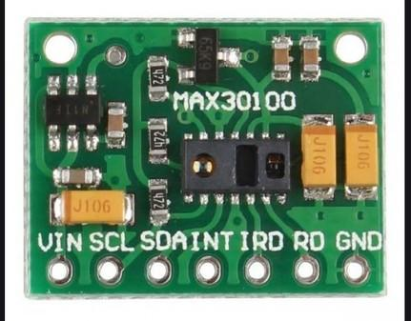

**Figure 2.1: MAX30100 heartbeat sensor**

#### *Features*

* Integrated LEDs, photo sensor, and high-performance analog front-end.
* Tiny 5.6mm x 2.8mm x 1.2mm 14-Pin optically enhanced system-in-package.
* Programmable sample rate and LED current for Power Savings
* Ultra-Low Shutdown Current (0.7μA, typ)

*Pin configuration*

Table 2.1:Pin configuration of MAX30100 heartbeat sensor

|  |  |
| --- | --- |
| **Pin Type** | **Pin Function** |
| VIN | Voltage Input |
| SCL | I2C - Serial Clock |
| SDA | I2C - Serial Data |
| INT | Active low interrupt |
| IRD | IR LED Cathode and LED Driver Connection Point(Leave floating in the circuit) |
| RD | Red LED Cathode and LED Driver Connection Point(Leave floating in the circuit) |
| GND | Ground pin |

*Benefits*

* Ultra-Low-Power Operation Increases Battery Life for Wearable Devices
* High SNR Provides Robust Motion Artifact Resilience
* Integrated Ambient Light Cancellation
* High Sample Rate Capability
* Fast Data Output Capability

### Temperature sensor

A temperature sensor is an electronic device that measures the temperature of its environment and converts the input data into electronic data to record, monitor, or signal temperature changes. There are many different types of temperature sensors. Some temperature sensors require [direct contact](https://www.electronics-tutorials.ws/io/io_3.html) with the physical object that is being monitored (contact temperature sensors), while others indirectly measure the temperature of an object (non-contact temperature sensors).  Non-contact temperature sensors are usually infrared (IR) sensors. They remotely detect the IR energy emitted by an object and send a signal to a calibrated electronic circuit that determines the object's temperature.

Among the contact temperature sensors are [thermocouples and thermistors](https://www.digikey.com/en/articles/techzone/2011/oct/temperature-sensors-the-basics). A thermocouple is comprised of two conductors, each made of a different type of metal, that [are joined at an end](https://www.omega.com/en-us/resources/thermocouples) to form a junction. When the junction is exposed to heat, a voltage is generated that directly corresponds to the temperature input. This happens on account of the phenomena called the [thermoelectric effect](https://www.newworldencyclopedia.org/entry/Thermoelectric_effect). Thermocouples are generally inexpensive, as their design and materials are simple. The other type of contact temperature sensor is called a thermistor. In thermistors, resistance decreases as temperature increases. There are two main types of thermistors: [Negative Temperature Coefficient](https://www.ametherm.com/thermistor/what-is-an-ntc-thermistor) (NTC) and [Positive Temperature Coefficient](http://www.resistorguide.com/ptc-thermistor/) (PTC). Thermistors are more precise than thermocouples (capable of measuring [within 0.05-1.5 degrees Celsius](https://www.omega.co.uk/temperature/z/thermocouple-RTD.html)), and they are made of [ceramics or polymers.](http://www.resistorguide.com/ntc-thermistor/) Resistance Temperature Detectors (RTD) are essentially the metal counterpart of thermistors, and they are the most precise and expensive type of temperature sensors. In this project, TMP36 is the proposed sensor.

**TMP36 Temperature Sensor**

The TMP36 as shown in Figure 2.3 [19] is a low voltage, precision centigrade temperature sensor. It provides a voltage output that is linearly proportional to the Celsius temperature. It also doesn't require any external calibration to provide typical accuracies of ±1°C at +25°C and ±2°C over the −40°C to +125°C temperature range. We like it because it's so easy to use: Just give the device a ground and 2.7 to 5.5 VDC and read the voltage on the Vout pin. The output voltage can be converted to temperature easily using the scale factor of 10 mV/°C.

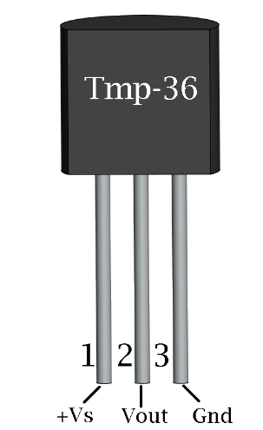

**Figure 2.2: TMP36 Temperature Sensor**

*Features*

* Voltage Input: 2.7 V to 5.5 VDC
* 10 mV/°C scale factor
* ±2°C accuracy over temperature
* ±0.5°C linearity
* Operating Range: −40°C to +125°C

*Pin configuration*

Table 2.2: Pin configuration of TMP36 Temperature Sensor

|  |  |
| --- | --- |
| **Pin Type** | **Pin Function** |
| +Vs | Positive supply pin |
| Vout | Output voltage pin |
| GND | Ground pin |

*Benefits*

* Small size, low cost
* Easy to integrate
* External calibration is not required
* Low self-heating qualified for automotive applications

*Applications Examples:*

* Environmental control systems
* Thermal protection
* Industrial process control
* Fire alarms
* Power system monitors
* CPU thermal management

### Accelerometer and Gyroscope Sensor

MEMS (Micro Electro Mechanical Systems) accelerometer consists of a micro-machined structure built on top of a silicon wafer. This structure is suspended by polysilicon springs. It allows the structure to deflect at the time when the acceleration is applied on the particular axis. Due to deflection the capacitance between fixed plates and plates attached to the suspended structure is changed. This change in capacitance is proportional to the acceleration on that axis. The sensor processes this change in capacitance and converts it into an analog output voltage.

While accelerometers measure linear acceleration, MEMS gyroscopes measure angular rotation. To do this they measure the force generated by what is known as The Coriolis Effect. Coriolis Effect tells us that when a mass (m) moves in a particular direction with a velocity (v) and an external angular rate (Ω) is applied (Red arrow); the Coriolis Effect generates a force (Yellow arrow) that causes a perpendicular displacement of the mass. The value of this displacement is directly related to the angular rate applied. Now suppose that there are two masses that are kept in constant oscillating motion so that they move continuously in opposite directions. When angular rate is applied, the Coriolis effect on each mass is also in opposite directions, which results in a change in the capacitance between them; this change is sensed.

**MPU-6050 Accelerometer + Gyro**

This board includes an MPU-6050 6-Axis Motion Processing Unit, a 2.5V voltage regulator, and the logic level converter circuit to makes it work under the power of 3V-5V. Based on its I2C communication protocol, you can use very few wires to connect it with a 3V-5V MCU directly as shown in Figure 2.4 [19].

The MPU-6050 sensor contains a MEMS accelerometer and a MEMS gyro in a single chip. It is very accurate, since it contains 16-bits analog to digital conversion hardware for each channel. Therefor it captures the x, y, and z channel at the same time.

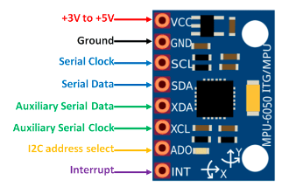

**Figure 2.3: MPU6050 Accelerometer + Gyro**

*Electronic Features :*

* Name: MPU-6050 module (three-axis gyroscope + triaxial accelerometer)
* Chip: MPU-6050
* Power supply: 3V-5V power(internal low dropout regulator)
* Gyroscope range: + 250 500 1000 2000 ° / s
* Acceleration range: ± 2 ± 4 ± 8 ± 16 g
* Communication Mode: standard IIC communication protocol
* Chip built-in 16-bit AD converter, 16 bits data output
* Pin pitch 2.54 mm
* Size: 20.3mm x 15.6mm
* Immersion Gold PCB, machine welding process to ensure quality

*Pin configuration*

Table 2.3: Pin configuration of MPU6050 Accelerometer + Gyro

|  |  |
| --- | --- |
| **Pin Type** | **Pin Function** |
| VCC | Provides power for the module, can be +3V to +5V. Typically +5V is used. |
| GND | Connected to Ground of system. |
| SCL | I2C - Serial Clock. Used for providing clock pulse for I2C Communication. |
| SDA | I2C - Serial Data. Used for transferring Data through I2C communication. |
| XDA | Auxiliary Serial Data. Can be used to interface other I2C modules with MPU6050. It is optional. |
| XCL | Auxiliary Serial Clock. Can be used to interface other I2C modules with MPU6050. It is optional. |
| AD0 | If more than one MPU6050 is used a single MCU, then this pin can be used to vary the address. |
| INT | Interrupt pin to indicate that data is available for MCU to read. |

### GPS Module

One of the global positioning systems (GPS) devices utilizes data from satellites to locate a specific point on the Earth in a process named trilateration. Meanwhile, a GPS receiver measures the distances to satellites using radio signals to trilaterate. And trilateration is similar to triangulation, which measures angles, depicted in this illustration (Tim Gunther, 2020). GPS modules contain tiny processors and antennas that directly receive data sent by satellites through dedicated RF frequencies. From there, it’ll receive timestamp from each visible satellites, along with other pieces of data. If the module’s antenna can spot 4 or more satellites, it’s able to accurately calculate its position and time.

**NEO-6MV2 GPS Module**

The NEO-6MV2 is a GPS (Global Positioning System) module and is used for navigation. The module simply checks its location on earth and provides output data which is longitude and latitude of its position. It is from a family of stand-alone GPS receivers featuring the high-performance u-blox 6 positioning engine. These flexible and cost-effective receivers offer numerous connectivity options in a miniature (16 x 12.2 x 2.4 mm) package. The compact architecture, power and memory options make NEO-6 modules ideal for battery operated mobile devices with very strict cost and space constraints. Its Innovative design gives NEO-6MV2 excellent navigation performance even in the most challenging environments.

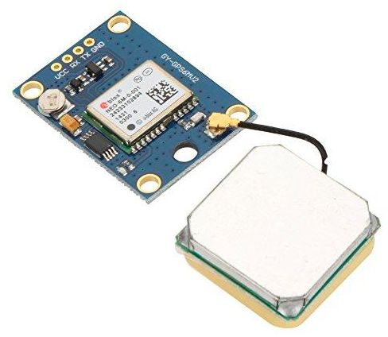

**Figure 2.4: NEO-6MV2 GPS Module**

*Features and Electrical Characteristics*

* Standalone GPS receiver
* Anti-jamming technology
* UART Interface at the output pins (Can use SPI ,I2C and USB by soldering pins to the chip core)
* Under 1 second time-to-first-fix for hot and aided starts
* Receiver type: 50 Channels - GPS L1 frequency - SBAS (WAAS, EGNOS, MSAS, GAGAN)
* Time-To-First-fix:  For Cold Start 32s, For Warm Start 23s, For Hot Start <1s
* Maximum navigation update rate: 5Hz
* Default baud rate: 9600bps
* EEPROM with battery backup
* Sensitivity: -160dBm
* Supply voltage: 3.6V
* Maximum DC current at any output: 10mA
* Operation limits: Gravity-4g, Altitude-50000m, Velocity-500m/s
* Operating temperature range: -40ºC TO 85°C

Table 2.4: Pin configuration of NEO-6MV2 GPS Module

|  |  |
| --- | --- |
| **Pin Type** | **Pin Function** |
| VCC | Positive supply pin |
| RX | UART receive pin |
| TX | UART transmit pin |
| GND | Ground pin |

### GSM/GPRS Module

A GSM module or a GPRS module is a chip or circuit that will be used to establish communication between a mobile device or a computing machine and a GSM or GPRS system. The modem (modulator-demodulator) is a critical part here.

These modules consist of a GSM module or GPRS modem powered by a [power supply circuit](https://www.electronicsforu.com/electronics-projects/plus-minus-5v-supply-from-9v-battery) and communication interfaces (like RS-232, USB 2.0, and others) for computer. A GSM modem can be a dedicated modem device with a serial, USB or [Bluetooth](https://www.electronicsforu.com/?s=bluetooth) connection, or it can be a mobile phone that provides GSM modem capabilities.

**SIM800L GSM MODULE**

The SIM800L as shown in Figure 2.5 [20] is a GSM module from Simcom that gives any microcontroller GSM functionality, meaning it can connect to the mobile network to receive calls and send and receive text messages, and also connect to the internet using GPRS, TCP, or IP. Another advantage is that the board makes use of existing mobile frequencies, which means it can be used anywhere in the world.

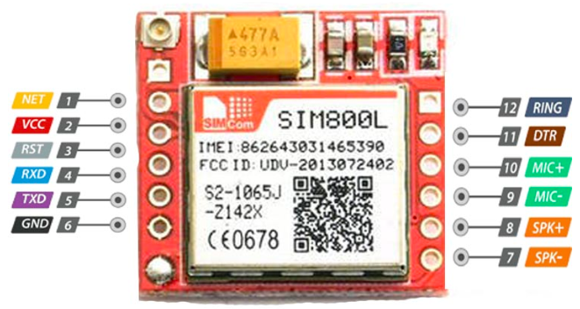

**Figure 2.5: SIM800L GSM module**

*Pin configuration*

Table 2.5: Pin configuration of SIM800L GSM module

|  |  |  |
| --- | --- | --- |
| **Pin number** | **Pin name** | **Description** |
| 1 | NET | External antenna attachment pin |
| 2 | VCC | Power supply pin, 3.4V to 4.4V input |
| 3 | RST | Reset pin, pull low for 100ms to perform hard reset |
| 4 | RXD | Serial data input |
| 5 | TXD | Serial data output |
| 6 | GND | Module ground reference |
| 7, 8 | SPK | Speaker differential output |
| 9, 10 | MIC | Microphone differential input |
| 11 | DTR | Serial data terminal ready pin, pull high to enable sleep mode |
| 12 | RING | Interrupt output, active low |

*Features*

* Full modem serial port
* Two microphone inputs and speaker output
* SIM card interface
* Supports FM and PWM
* Sleep mode with 0.7mA current

### Force Sensor (FSR)

FSR 400 force sensor or force-sensing resistor is made of a conducting polymer whose resistance changes when external force or pressure is applied to it. The conductive polymer material has the property of increasing resistance when force or pressure is applied on its conductive surface. The force sensing resistor has a thin size, low cost, and good shock resistance. However, readings obtained from multiple force sensors will have a considerable difference between them causing them to have low precision. It has many applications such as in the automobile industry like car sensors, resistive touchpads, musical instruments, keypads, portable electronics systems, and foot pronation systems.

Force sensing resistor works on two principles. The first one is percolation in which conductive polymer material particles move and filter. The second one is quantum tunneling in which conductive polymer material particles pass through a potential barrier. Both of these principles can occur simultaneously during working conditions of the FSR. However, one dominates the other one and this depends upon the polymer material.

Every force-sensing resistor consists of two pins. The first one is directly connected to VCC and the second one is connected to the ground through a pull-down resistor. There is a point between the pull-down resistor and force sensing resistor shown in the figure below, this point is directly connected to an analog input of any controller which is used with this sensing resistor for measuring purposes. In this project we will use the RP-S40-ST Thin Film Pressure Sensor

**RP-S40-ST Thin Film Pressure Sensor**

This is a square flexible thin film pressure sensor of short legs with a side length of 40mm, which can be used to realize highly sensitive detection of pressure. The sensor is durable and designed to sense static and dynamic pressure in a high respond speed. Its advantages of recording the intensity and frequency of force make it widely used in all kinds of applications, such as, pressure switch, bed monitoring system, intelligent sneaker and medical device system. These sensors are also very easy to use.

RP-C flexible pressure sensor is made of ultra-thin film of excellent mechanical property, excellent conductive materials and nanometer pressure sensitive layers. There are thin film and pressure sensitive layer on the upper layer of the sensor, and thin film and conductive circuit on the lower layer. These two layers are glued together by double sided tape. When outside pressure applies to the active area, the disconnected circuit of the lower layer will be connected through the pressure sensitive layer of the upper layer, by which to convert pressure into resistance. The output resistance decreases as pressure increases.

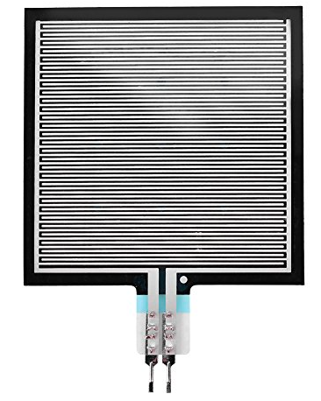

**Figure 2.6: RP-S40-ST Thin Film Pressure Sensor**

*Features*

* Thickness: 0.45mm
* Trigger Force: 20g, triggered (default resistance<200kΩ)
* Pressure Measuring Range: 20g~10kg
* Static Pressure & Dynamic Pressure Measurement (within the frequency of 10Hz)
* Initial Resistance: >10MΩ
* Activation Time: <0.01S
* Operating Temperature: -40℃~+85℃
* Lifespan: >1million times
* Hysteresis: +10%，(RF+ -RF-)/FR+，1000g Force
* Response Time: <10ms
* EMI: Not generate
* EDS: Not generate
* Drift: <5%, 2.5Kg Force , Static load 24H

## CONCULUSION

For this project, I shall use the Arduino Mega 2560 board as it is cheap and user-friendly. Communication will be through cellular data using Global System for Mobile Communication (GSM) board. SIM800L GSM module will be used as the GSM module as it makes use of existing mobile frequencies, and NEO-6MV2 GPS Module will be used as the GPS module as it’s from a family of stand-alone GPS receivers featuring the high-performance u-blox 6 positioning engine. The MAX30100 heart beat sensor will be used as it has ultra-low-power operation, increases battery life for wearable devices, high snr provides robust motion artifact resilience. integrated ambient light cancellation, high sample rate capability and fast data output capability. The TMP36 Temperature Sensor will be used in this case as it is of a small size, low cost, easy to integrate, and has external calibration is not required. The MPU6050 Accelerometer + Gyro will be used as it contains a MEMS accelerometer and a MEMS gyro in a single chip and it is very accurate. RP-S40-ST Thin Film Pressure Sensor will also be used in this case as it records the intensity and frequency of force.

CHAPTER THREE

# METHODOLOGY

## **PROPOSED** **SYSTEM**

Temperature sensor

Heart bit sensor

GSM module

Arduino microcontroller

Accelerometer and gyroscope module

Pressure sensor

Buzzer module

GPS module

**Figure 3.1: Block diagram of proposed system**

The functionality of **Figure 3.1**is as illustrated below;

1. It uses a cellular communication module to transmit data via text. This data is sent by the transmitter and the receiver side receives the data from the transmitter.
2. It uses a heart rate sensor, temperature sensor, pressure sensor, GSM/GPS module and an accelerometer gyroscope to collect information concerning a patient’s status.
3. The heart rate sensor measures the worker’s heart rate in Beats per Minute using an optical LED light source and an LED light sensor. The light shines through the skin, and the sensor measures the amount of light that reflects back. The light reflections will vary as blood pulses under the skin passes the light. The variations in the light reflections are interpreted as heartbeats.
4. The temperature sensor measures the worker’s temperature and send a signal to a calibrated electronic circuit that determines the object's temperature.
5. The Global Positioning System (GPS) module accurately calculates a worker’s position and time anywhere on earth if the module’s antenna can spot 4 or more satellites.
6. Gyroscope sensor combined with accelerometer sensor is used to detect falls and send alerts to caregivers. The accelerometer provides information regarding body inertial changes due to impact; the gyroscope provides information regarding the body’s rotational velocity during a fall event.
7. A microcontroller board will be used to process and control the data.
8. A pressure/force sensor is used to detect concussive forces from impacts or due to a fall and provide information on the impact sustained.

The flowcharts and block diagram below shall be used as a rough concept of the application's process.

## FALL DETECTION

**Figure 3.2: Block diagram of the fall detection system**

Pre-fall

Fall Detection

After-impact fall

Wearable sensors

Wearable sensors

Some methods that are based on the threshold used in the detection of fall are Accelerometer Amplitude, Resultant Acceleration, and Signal Vector Magnitude methods. Resultant Acceleration, Accelerometer Amplitude, and Signal Vector Magnitude methods basically have very similar formulas:

$Asum=\sqrt{{Ax}^{2}+Ay^{2}+Az^{2}}$ (1)

Equation (1) is the formula of Resultant Acceleration method, where AX, AY, and AZ represent the acceleration on the X, Y, and Z axes in accelerometer sensor.

### Accelerometer Gyroscope Vector Signal Resultant (AGVeSR)

By using the Resultant Acceleration formula, the accelerometer sensor, which has X, Y, and Z axes (AX, AY, and AZ), calculates based on the signals that pass some thresholds to detect fall.

AGVeSR combines both accelerometer and gyroscope sensors, and a total of six values are extracted from each axis.

$AGVeSR=\sqrt{( {\left(\left|AX\right|+GX\right)}^{2}+{{\left(\left|AY\right|+GY\right)}^{2}+ \left(\left|AZ\right|+GZ\right)}^{2})}$ (2)

AX, AY, and AZ represent acceleration on the X, Y, and Z axes in accelerometer, and GX, GY, and GZ represent acceleration on the X, Y, and Z axes in gyroscope. The benefit of the implementation of this formula is that it does not detect fall based on specific orientations as it applies absolute notation. If a certain axis has a negative value, the value will be converted into positive thanks to the application of absolute notation.

Linear Acceleration (Ali) and Sum Vector of Linear Acceleration (Alim) to distinguish between fall and non-fall actions, a sum vector value that excludes the gravity vector should be calculated to count linear acceleration (Ali) and sum vector of it (Alim) [23]. AX, AY, and AZ are the acceleration on the X, Y, and Z axes in accelerometer. GX, GY, and GZ represent the acceleration on the X, Y, and Z axes in gyroscope. We implemented Ali (3) and Alim (4) to accommodate our research problem without depending on smartphone positions.

$Ali=[\left( AX-GX\right), \left(AY-GY\right), (AZ-GZ)]$ (3)

$Alim=\left|Ali\right|$ (4)

### Alpha Degree (∠α)

Since body posture will change when fall occurs, the worker’s angle needs to be measured using∠Y. This formula is based on the acceleration on the X, Y, and Z axes in accelerometer (AX, AY, and AZ). The inclination between the worker when falling and the ground plane can be computed with the help of the accelerometer sensor. If the angle calculated has a value of more than the specified threshold (60°), it means that a fall has occurred.

$Y=tan^{-1}\left[\frac{AY}{\sqrt{{Ax}^{2}+Ay^{2}}}\right]$ (5)

Before calculating ∠α, the algorithm should have determined the highest axis absolute value of the accelerometer.

(6)

Collect data from MPU6050 sensor

Calculate acceleration magnitude (AM)

AM breaks lower threshold?

AM breaks upper threshold?

Orientation change in range within 5s?

Orientation remains after 10s?

Fall detected/Alert worker via microphone

yes

yes

yes

no

no

no

no

yes

**Figure 3.3: Fall Detection Flow Chart**

### Gyroscope Resultant Distance (GyroRe)

Gyroscope signals have a sudden high spike when a fall occurs (Fig. 1(b)). This spike can be used in the fall detection method because it can indicate the sudden movement caused when someone falls.

$GyroRe=\sqrt{{Gx}^{2}+Gy^{2}+Gz^{2}}$ (7)

GyroRe (7) is based on X, Y, and Z axes in gyroscope (GX, GY, and GZ). If the GyroRe exceeds the specific threshold, it means that a fall has occurred.

**AFTER-FALL IMPACT FLOWCHART**

Fall detected/Alert worker via microphone

Initialize the parameters of the pressure sensor

Read the pressure sensor value.

Is force sustained is > 100g?

Send SMS message to supervisor & medical team with worker name and GPS location.

no

yes

**Figure 3.4: After Fall Impact Flow Chart**

**PHYSIOLOGICAL PARAMETERS FLOWCHART**

no

yes

Initialize parameters; heartbeat, body temp, location

Read GPS location from GPS module

Read heartbeat sensor;

Read temperature sensor;

Is heart rate < 60 or >100?

Is temperature < 36.1 C or >37.2 C?

Send SMS message to supervisor & medical team with worker name, heartbeat and temperature value and GPS location. Alert worker via microphone.

Wait for long delay(5 minutes)

**Figure 3.5: Physiological Parameters Flowchart**

## CIRCUIT DESIGN

### Interfacing TMP36 Temperature Sensor with Arduino

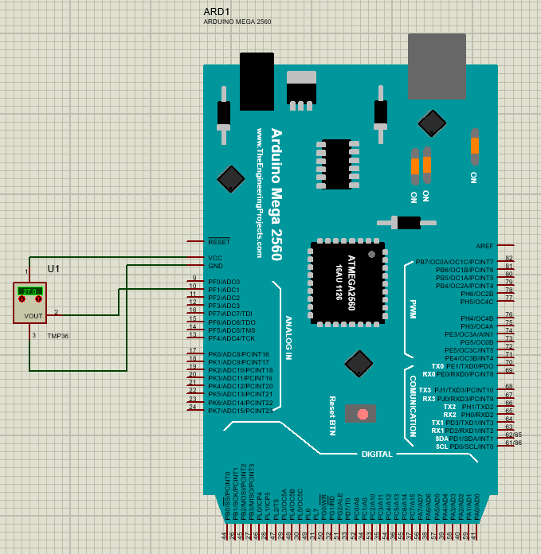

**Figure 3.6: Interfacing TMP36 Temperature Sensor with Arduino**

The code is shown in APPENDIX 1.

### Interfacing RP-S40-ST Thin Film Pressure Sensor with Arduino

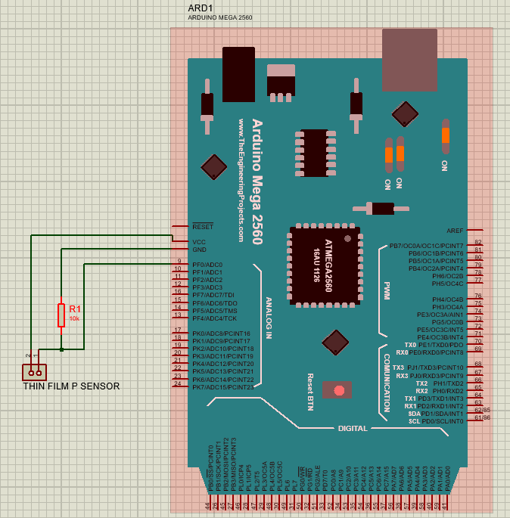

**Figure 3.7: Interfacing RP-S40-ST Thin Film Pressure Sensor** **with Arduino**

The code is shown in APPENDIX 2.

### ****Interfacing**** the Buzzer ****with Arduino****

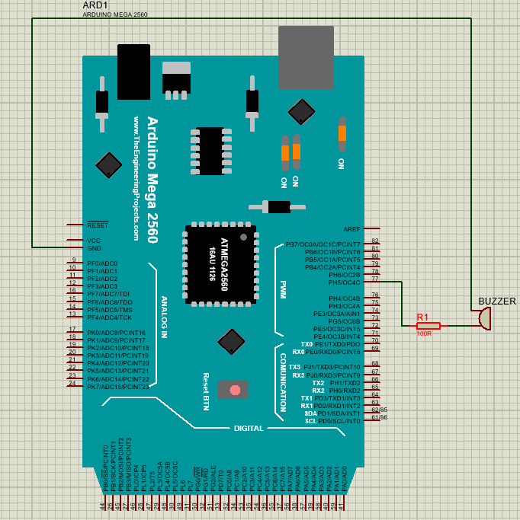

**Figure 3.8: Interfacing the Buzzer with Arduino**

The code is shown in APPENDIX 3.

### Interfacing MPU6050 Accelerometer + Gryo Sensor with Arduino

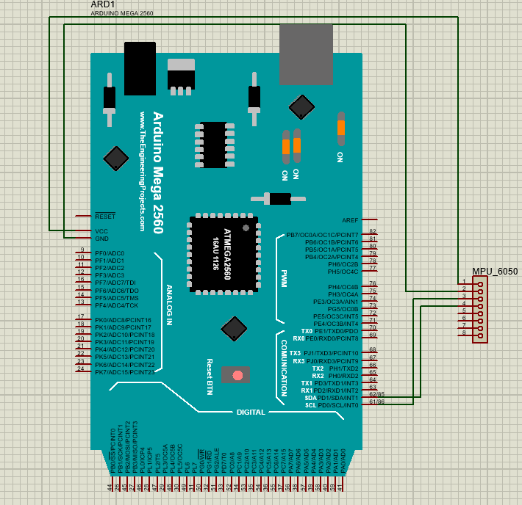

**Figure 3.9: Interfacing MPU6050 Accelerometer + Gryo Sensor** **with Arduino**

The code is shown in APPENDIX 4.

### Interfacing MAX30100 Heart Beat Sensor with Arduino

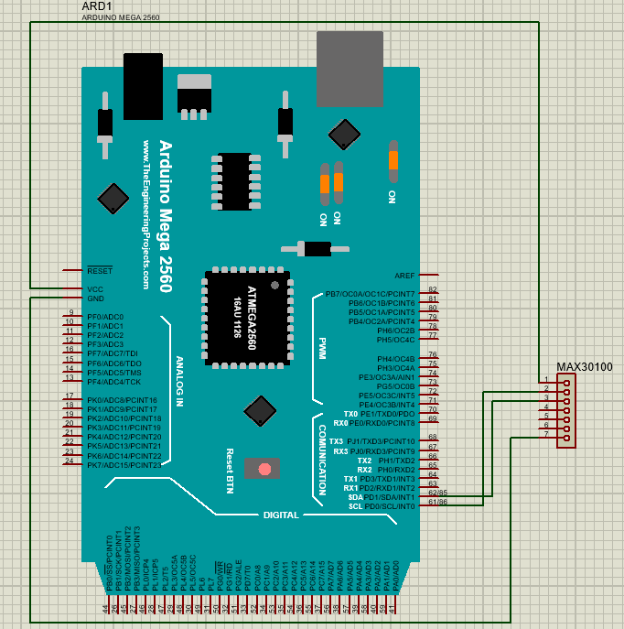

**Figure 3.10: Interfacing MAX30100 Heart Beat Sensor** **with Arduino**

The code is shown in APPENDIX 5.

### Interfacing NEO-6M GPS Module with Arduino

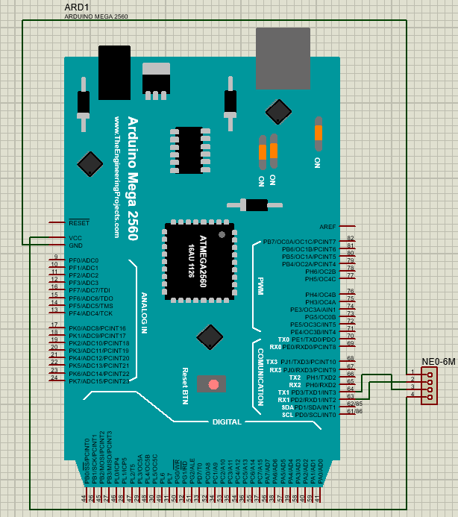

**Figure 3.11: Interfacing NEO-6M GPS Module with Arduino**

The code is shown in APPENDIX 6.

### Interfacing SIM800L GSM Module with Arduino

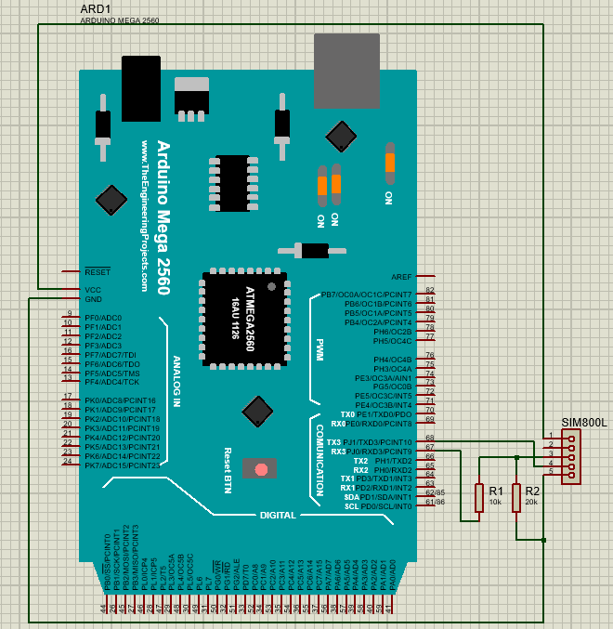

**Figure 3.12: Interfacing SIM800L GSM Module with Arduino**

**Analysis of the resistor network**

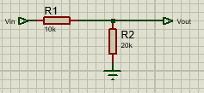

During transmission from Arduino, the voltage is 5V, hence voltage divider network scales down the voltage entering the GSM module.

$$Vout= \frac{VinR1}{R1+R2}$$



The code is shown in APPENDIX 7.

### Overall circuit diagram

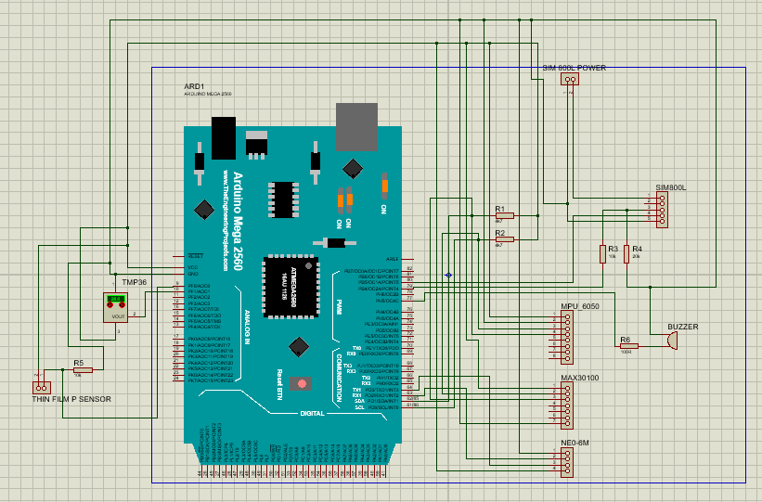

**Figure 3.13: Overall circuit diagram**

The code is shown in APPENDIX 8.

CHAPTER FOUR

# RESULTS AND ANALYSIS

## HARDWARE DESIGN

This project emulates a smart hardhat and an external wearable device.

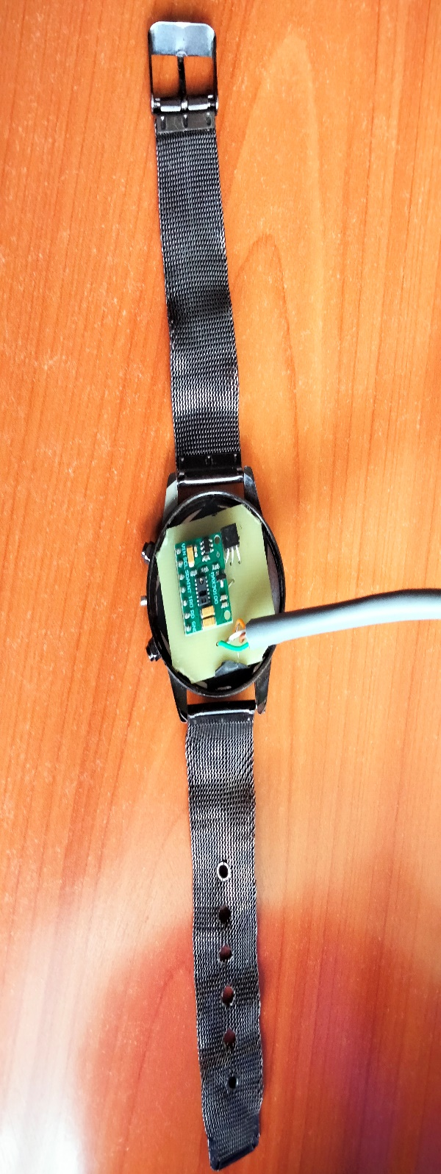

**Figure 4.1: An external wearable device**

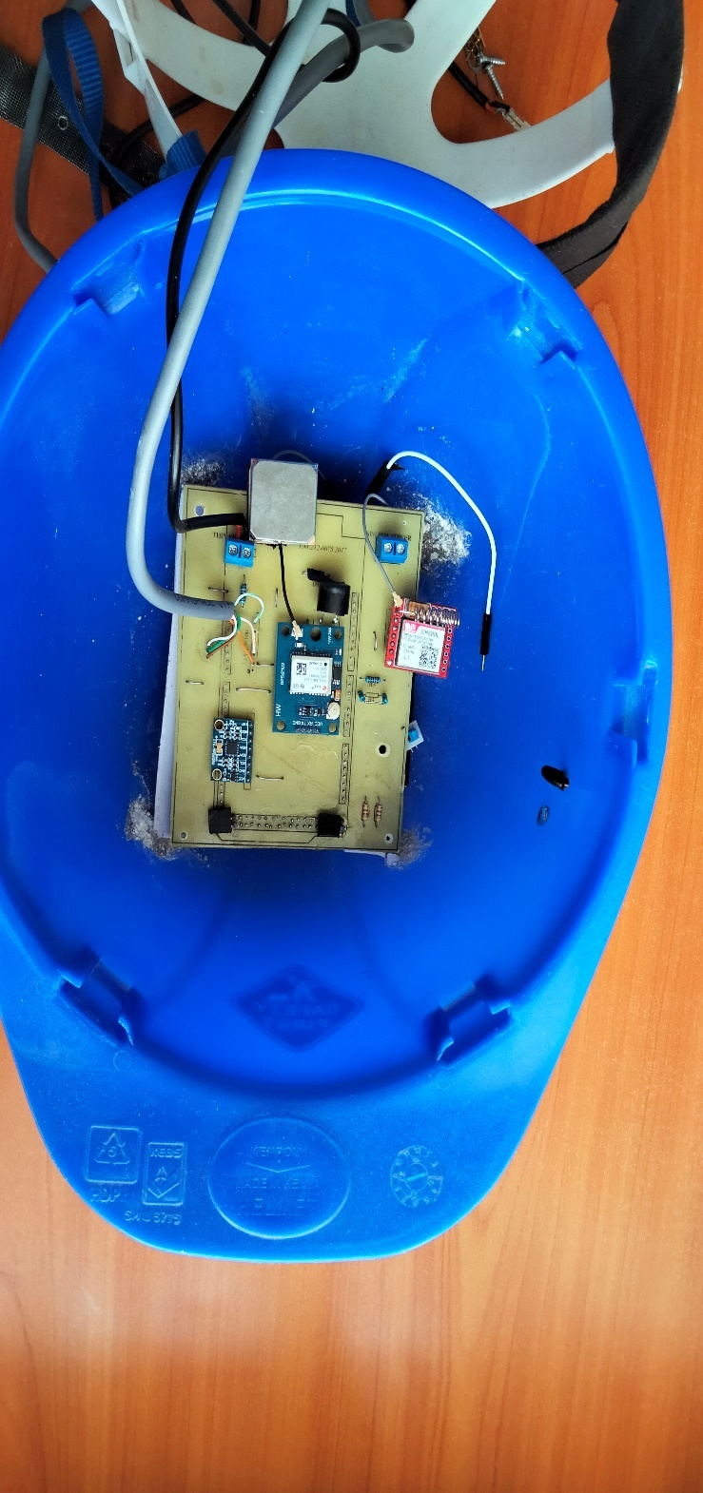

**Figure 4.2: A smart hardhat**

## SOFTWARE DESIGN ANALYSIS

The Arduino Mega 2560 microcontroller process the workers’ data from the MAX30100 heart beat sensor, MPU6050 Accelerometer + Gyro, RP-S40-ST Thin Film Pressure Sensor and NEO-6MV2 GPS Module and outputs the alert through the buzzer and the SIM800L GSM module.

### SIM800L GSM module output

The SIM800L GSM module sends texts to both the site manager and also the emergency health team, also there’s a provision of a call incase the involved parties did not get the text.

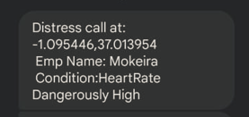

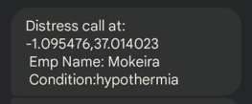

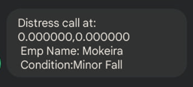



# CHAPTER FIVE

# CONCULION AND RECOMMENDATIONS

## CONCLUSION

In this project, a smart hardhat and an external wearable device has been designed. From the design steps undertaken, it is clear that constant monitoring of construction workers in the sites is crucial and so is the need of a smart protective personal equipment.

Moreover, the project scope was limited to the use of 3 sensors and a wireless communication system and the focus was on the hard hat and wearable device. Thus, replication of this project would be easy when other parts of the personal protective equipment are considered for designing a full smart PPE from head to toe.

Finally, the project objectives were met as per the indicated methodology and hence analysis for the final designed smart PPE. Implementation of the smart PPE design would reduce the number of accidents and fatalities occurring in construction sites.

## RECOMMENDATION

Given the scope of this project’s objectives, other opportunities that arise to enhance the design of a smart PPE include;

* Two-way communication for safety alerts.
* Data storage so as to be used for prediction.
* Calibrating unique thresholds for each worker.
* A water proof hardware.

# BUDGET

Table 5.1: Budget

|  |  |  |  |  |
| --- | --- | --- | --- | --- |
| Item | Description | Quantity | Rate | Amount |
| 1 | Arduino Mega 2560 board | 1 | 2000 | 2000 |
| 2 | SIM800L GSM module | 1 | 800 | 800 |
| 3 | MAX30100 Heart beat sensor | 1 | 450 | 450 |
| 4 | TMP36 Temperature Sensor | 1 | 200 | 200 |
| 5 | MPU6050 Accelerometer + Gyro | 1 | 300 | 300 |
| 6 | RP-S40-ST Thin Film Pressure Sensor | 1 | 500 | 500 |
| 7 | NEO-6MV2 GPS Module | 1 | 800 | 800 |
| 8 | Lithium battery 3.7V 2000mAh | 1 | 600 | 600 |
| 9 | Push Button Self Locking | 1 | 10 | 10 |
| 10 | Printing | 4 | 500 | 2000 |
| 11 | Miscellaneous |  |  | 1000 |
| TOTAL | | | | 8650 |

# PROJECT TIME PLAN

Table 6.1: Work Plan

|  |  |  |  |  |  |  |  |  |
| --- | --- | --- | --- | --- | --- | --- | --- | --- |
| **ACTIVITIES** | **MAY** | **JUN** | **JUL** | **AUG** | **SEP** | **OCT** | **NOV** | **DEC** |
| **Documentation** |  |  |  |  |  |  |  |  |
| **Proposal Writing** |  |  |  |  |  |  |  |  |
| **Literature Review** |  |  |  |  |  |  |  |  |
| **Proposal Presentation** |  |  |  |  |  |  |  |  |
| **Design and coding** |  |  |  |  |  |  |  |  |
| **Hardware**  **configuration, testing and adjustment** |  |  |  |  |  |  |  |  |
| **Final Report writing** |  |  |  |  |  |  |  |  |
| **Final Presentation** |  |  |  |  |  |  |  |  |

# REFERENCES

|  |  |
| --- | --- |
| [1] | S. Macpherson, "The Top Causes of Workplace Injuries and Fatalities," The Checker, [Online]. Available: https://www.thechecker.net/stories/blog/the-top-causes-of-workplace-injuries-and-fatalities. |
| [2] | G. V. Research, *Personal Protective Equipment Market Size, Share & Trends Analysis Report By Product (Respiratory Protection, Protective Clothing), By End-use (Healthcare, Manufacturing), By Region, And Segment Forecasts,* 2021-2028. |
| [3] | Zek, *LifeBEAM Smart Hat-Measure Your Heart Rate in Style!,* 2015. |
| [4] | B. Griggs, "Smart Football Helmet May Help Detect Concussions - CNN.com," CNN. Cable News. [Online]. |
| [5] | B. ZARDA, "A Smart Football Helmet Monitors Players’ Health," *A Smart Football Helmet Monitors Players’ Health,* JUN 9, 2009. |
| [6] | A. Chanthadavong, "Laing O'Rourke monitors workers' safety with a smart hardhat," ZDNet, 17 November 2015. [Online]. |
| [7] | P. Pittsburgh, "SOLEPOWER LAUNCHES SELF-POWERED SMARTBOOTS," SolePower, 6 February 2017. [Online]. Available: http://www.solepowertech.com/pr-smartboots. |
| [8] | "SAFETY HAZARDS CONSTRUCTION WORKERS NEED TO KNOW ABOUT," [Online]. Available: https://weeklysafety.com/blog/common-construction-site-safety-hazards. |
| [9] | D. a. M. G. e. Raychaudhuri, Emerging wireless technologies and the future mobile internet., Cambridge University Press, 2011. |
| [10] | J. C. Whitaker, Radio Frequency Transmission Systems: Design and Operation, McGraw-Hill: Intertext Publications, 1991. |
| [11] | admin, " Different Types of Wireless Communication Technologies," WatElectronics.com , 5 January 2021. [Online]. |
| [12] | A. Thakur, "Microwave Transmission," tutorialspoint, 22 June 2020. [Online]. Available: https://www.tutorialspoint.com/Microwave-Transmission. |
| [13] | S. D. a. V. S. G. Padiya, " Analysis of Bluetooth Versions (4.0, 4.2, 5, 5.1, and 5.2) for IoT Applications," in *Implementing Data Analytics and Architectures for Next Generation Wireless Communications*, IGI Global, 2022, pp. pp. 153-178. |
| [14] | S. J. L. a. M. Y. Ding, "The use of ZigBee wireless communication technology in industrial automation control," *Wireless Communications and Mobile Computing,* 2021. |
| [15] | C. O. O. Adeogun, "Integration of Wireless Broadband Networks With WiMax To Provide Reliable Internet Access to Subscribers". |
| [16] | "Different Microcontroller Boards and their Applications," elprocus.com, [Online]. Available: https://www.elprocus.com/different-types-of-microcontroller-boards/. |
| [17] | E. Odunlade, "GETTING STARTED WITH THE NODEMCU (ESP8266 BASED DEVELOPMENT BOARD)," https://www.electronics-lab.com/, 22 April 2020. [Online]. |
| [18] | "MI:power Board for BBC micro:bit V2," core-electronics.com, [Online]. Available: https://core-electronics.com.au/mi-power-board-for-bbc-micro-bit.html. |
| [19] | "Components101," Components101, 17 March 2021. [Online]. Available: https://components101.com/sensors/mpu6050-module. |
| [20] | " Ai-Thinker A9G GPS GSM GPRS Development Board GPRS Module GPS Module Wifi," Ai Thinker, [Online]. Available: https://ai-thinker.en.alibaba.com/product/62232000797-813211512/Ai\_Thinker\_A9G\_GPS\_GSM\_GPRS\_Development\_Board\_GPRS\_Module\_GPS\_Module\_Wifi.html. |
| [21] | "Different Microcontroller Boards and their Applications," elprocus.com, [Online]. Available: https://www.elprocus.com/different-types-of-microcontroller-boards/. |

# APPENDIX

# APPENDIX 1: Interfacing TMP36 Temperature Sensor with Arduino code

// Define the analog pin, the TMP36's Vout pin is connected to

#define sensorPin1 A1

void setup() {

  // Begin serial communication at 9600 baud rate

  Serial.begin(9600);

}

void loop() {

  // Get the voltage reading from the TMP36

  int reading = analogRead(sensorPin1);

  // Convert that reading into voltage

  // Replace 5.0 with 3.3, if you are using a 3.3V Arduino

  float voltage = reading \* (5.0 / 1024.0);

  // Convert the voltage into the temperature in Celsius

  float temperatureC = (voltage - 0.5) \* 100;

  // Print the temperature in Celsius

  Serial.print("Temperature: ");

  Serial.print(temperatureC);

  Serial.print("\xC2\xB0"); // shows degree symbol

  Serial.print("C  |  ");

  // Print the temperature in Fahrenheit

  float temperatureF = (temperatureC \* 9.0 / 5.0) + 32.0;

  Serial.print(temperatureF);

  Serial.print("\xC2\xB0"); // shows degree symbol

  Serial.println("F");

  delay(1000); // wait a second between readings

}

# APPENDIX 2: Interfacing RP-S40-ST Thin Film Pressure Sensor with Arduino code

Connect one end of FSR to 5V, the other end to Analog 0.

Then connect one end of a 10K resistor from Analog 0 to ground

Connect LED from pin 11 through a resistor to ground

int fsrAnalogPin = 0; // FSR is connected to analog 0

int LEDpin = 9;      // connect Red LED to pin 11 (PWM pin)

int fsrReading;      // the analog reading from the FSR resistor divider

int LEDbrightness;

void setup(void) {

  Serial.begin(9600);   // We'll send debugging information via the Serial monitor

  pinMode(LEDpin, OUTPUT);

}

void loop(void) {

  fsrReading = analogRead(fsrAnalogPin);

  Serial.print("Analog reading = ");

  Serial.println(fsrReading);

  // we'll need to change the range from the analog reading (0-1023) down to the range

  // used by analogWrite (0-255) with map!

  LEDbrightness = map(fsrReading, 0, 1023, 0, 255);

  // LED gets brighter the harder you press

  digitalWrite(LEDpin, LEDbrightness);

  delay(100);

}

# APPENDIX 3: Interfacing Buzzer with Arduino code

const int buzzer = 8; //buzzer to arduino pin 9

void setup(){

  pinMode(buzzer, OUTPUT); // Set buzzer - pin 9 as an output

}

void loop(){

  tone(buzzer, 1000); // Send 1KHz sound signal...

  delay(1000);        // ...for 1 sec

  noTone(buzzer);     // Stop sound...

  delay(1000);        // ...for 1sec

}

# APPENDIX 4: Interfacing MPU6050 Accelerometer + Gyro Sensor with Arduino code

#include "Wire.h"

#include "I2Cdev.h"

#include "MPU6050.h"

const int mpu6050\_addr = 0x68;

MPU6050 mpu;

int16\_t ax, ay, az;

int16\_t gx, gy, gz;

struct MyData {

  byte X;

  byte Y;

  byte Z;

};

MyData data;

void setup()

{

  Serial.begin(115200);

  Wire.begin(mpu6050\_addr);

  mpu.initialize();

  //pinMode(LED\_BUILTIN, OUTPUT);

}

void loop()

{

  mpu.getMotion6(&ax, &ay, &az, &gx, &gy, &gz);

  data.X = map(ax, -17000, 17000, 0, 255 ); // X axis data

  data.Y = map(ay, -17000, 17000, 0, 255);

  data.Z = map(az, -17000, 17000, 0, 255);  // Y axis data

  delay(500);

  Serial.print("Axis X = ");

  Serial.print(data.X);

  Serial.print("  ");

  Serial.print("Axis Y = ");

  Serial.print(data.Y);

  Serial.print("  ");

  Serial.print("Axis Z  = ");

  Serial.println(data.Z);

}

# APPENDIX 5: Interfacing MAX30100 Heart Beat Sensor with Arduino code

#include <Wire.h>

#include "MAX30100\_PulseOximeter.h"

#define REPORTING\_PERIOD\_MS     1000

// Create a PulseOximeter object

PulseOximeter pox;

// Time at which the last beat occurred

uint32\_t tsLastReport = 0;

// Callback routine is executed when a pulse is detected

void onBeatDetected() {

    Serial.println("Beat!");

}

void setup() {

    Serial.begin(115200);

    Serial.print("Initializing pulse oximeter..");

    // Initialize sensor

    if (!pox.begin()) {

        Serial.println("FAILED");

        for(;;);

    } else {

        Serial.println("SUCCESS");

    }

  // Configure sensor to use 7.6mA for LED drive

  pox.setIRLedCurrent(MAX30100\_LED\_CURR\_7\_6MA);

    // Register a callback routine

    pox.setOnBeatDetectedCallback(onBeatDetected);

}

void loop() {

    // Read from the sensor

    pox.update();

    // Grab the updated heart rate and SpO2 levels

    if (millis() - tsLastReport > REPORTING\_PERIOD\_MS) {

        Serial.print("Heart rate:");

        Serial.print(pox.getHeartRate());

        Serial.print("bpm / SpO2:");

        Serial.print(pox.getSpO2());

        Serial.println("%");

        tsLastReport = millis();

         if (pox.getHeartRate() > 166)

    {

      Serial.print ("Heartrate Dangerously High");

      }

      else if (pox.getHeartRate() < 20 && pox.getHeartRate() > 15)

    {

      Serial.println("Heartrate Dangerously low");

      }

     else if (pox.getSpO2() < 95 && pox.getSpO2() > 60)

     {

     Serial.print("Blood oxygen level is low");

      }

      else if (pox.getHeartRate() == 0 && pox.getSpO2() <= 50)

    {

      Serial.println("No beat detected");

      }

    }

   }

# APPENDIX 6: Interfacing NEO-6M GPS module with Arduino code

//Connect with pin 18 and 19

#include <TinyGPS.h>

//long   lat,lon; // create variable for latitude and longitude object

float lat,lon;

TinyGPS gps; // create gps object

void setup(){

Serial.begin(9600); // connect serial

Serial.println("The GPS Received Signal:");

Serial1.begin(9600); // connect gps sensor

}

void loop(){

    while(Serial1.available()){ // check for gps data

    if(gps.encode(Serial1.read()))// encode gps data

    {

    gps.f\_get\_position(&lat,&lon); // get latitude and longitude

    Serial.print("Position: ");

    //Latitude

    Serial.print("Latitude: ");

    Serial.print(lat,6);

    Serial.print(",");

    //Longitude

    Serial.print("Longitude: ");

    Serial.println(lon,6);

   }

  }

}

# APPENDIX 7: Interfacing SIM800L GSM module with Arduino code

#include <SoftwareSerial.h>

//Create software serial object to communicate with SIM800L

SoftwareSerial mySerial(11, 10); //SIM800L Tx & Rx is connected to Arduino #3 & #2

void setup()

{

  //Begin serial communication with Arduino and Arduino IDE (Serial Monitor)

  Serial.begin(9600);

  //Begin serial communication with Arduino and SIM800L

  mySerial.begin(9600);

  Serial.println("Initializing...");

  delay(1000);

  mySerial.println("AT"); //Once the handshake test is successful, it will back to OK

  updateSerial();

  mySerial.println("AT+CSQ"); //Signal quality test, value range is 0-31 , 31 is the best

  updateSerial();

  mySerial.println("AT+CCID"); //Read SIM information to confirm whether the SIM is plugged

  updateSerial();

  mySerial.println("AT+CREG?"); //Check whether it has registered in the network

  updateSerial();

}

void loop()

{

  updateSerial();

}

void updateSerial()

{

  delay(500);

  while (Serial.available())

  {

    mySerial.write(Serial.read());//Forward what Serial received to Software Serial Port

  }

  while(mySerial.available())

  {

    Serial.write(mySerial.read());//Forward what Software Serial received to Serial Port

  }

}

# APPENDIX 8: Overall circuit Arduino code

 #include <Wire.h>

 #include "MAX30100\_PulseOximeter.h"

///GSM module

#include <SoftwareSerial.h>

//Create software serial object to communicate with SIM800L

SoftwareSerial mySerial(11, 10); //SIM800L Tx & Rx is connected to Arduino #11 & #10

/////GPS Module

//Connect with pin 18 and 19

#include <TinyGPS.h>

//long   lat,lon; // create variable for latitude and longitude object

float lat,lon;

TinyGPS gps; // create gps object

////max30100

#define sensorPin A0

#define sensorPin1 A1

#define REPORTING\_PERIOD\_MS     1000

// Create a PulseOximeter object

PulseOximeter pox;

// Time at which the last beat occurred

uint32\_t tsLastReport = 0;

// Callback routine is executed when a pulse is detected

void onBeatDetected() {

    Serial.println("Beat!");

}

/////end of max30100

 const int MPU\_addr = 0x68; // I2C address of the MPU-6050

 int16\_t AcX, AcY, AcZ, Tmp, GyX, GyY, GyZ;

 float ax = 0, ay = 0, az = 0, gx = 0, gy = 0, gz = 0;

 boolean fall = false; //stores if a fall has occurred

 boolean trigger1 = false; //stores if first trigger (lower threshold) has occurred

 boolean trigger2 = false; //stores if second trigger (upper threshold) has occurred

 boolean trigger3 = false; //stores if third trigger (orientation change) has occurred

 byte trigger1count = 0; //stores the counts past since trigger 1 was set true

 byte trigger2count = 0; //stores the counts past since trigger 2 was set true

 byte trigger3count = 0; //stores the counts past since trigger 3 was set true

 int angleChange = 0;

String workerLocation;

String message;

String employeeName;

String condition;

const int buzzer = 8; //buzzer to arduino pin 9

 void setup() {

   Serial.begin(9600);

   employeeName = "Mokeira";

   ////GPS module

Serial.begin(9600); // connect serial

Serial.println("The GPS Received Signal:");

Serial1.begin(9600); // connect gps sensor

   ////max30100

    Serial.print("Initializing pulse oximeter..");

    // Initialize sensor

    if (!pox.begin()) {

        Serial.println("FAILED");

        for(;;);

    } else {

        Serial.println("SUCCESS");

    }

  // Configure sensor to use 7.6mA for LED drive

  pox.setIRLedCurrent(MAX30100\_LED\_CURR\_7\_6MA);

    // Register a callback routine

    pox.setOnBeatDetectedCallback(onBeatDetected);

/////end of max30100

  pinMode(buzzer, OUTPUT); // Set buzzer - pin 9 as an output

   Wire.begin();

   Wire.beginTransmission(MPU\_addr);

   Wire.write(0x6B);  // PWR\_MGMT\_1 register

   Wire.write(0);     // set to zero (wakes up the MPU-6050)

   Wire.endTransmission(true);

   Serial.println("Wrote to IMU");

 }

 void loop() {

        while(Serial1.available()){ // check for gps data

    if(gps.encode(Serial1.read()))// encode gps data

    {

    gps.f\_get\_position(&lat,&lon); // get latitude and longitude

    /\*

    Serial.print("Position: ");

    //Latitude

    Serial.print("Latitude: ");

    Serial.print(lat,6);

    Serial.print(",");

    //Longitude

    Serial.print("Longitude: ");

    Serial.println(lon,6);

    \*/

   }

  }

  workerLocation = String(lat,6)+","+String(lon,6);

  int x=analogRead(sensorPin);// store the values of pressure sensor in variable x

  /////Temperature Measurement and function

  int reading = analogRead(sensorPin1);//store the values of tmp 36 temp sensor in variable reading

   float voltage = reading \* (5.0 / 1024.0);

    float temperatureC = (voltage - 0.5) \* 100;

    if (temperatureC >= 50){

      condition = "Fever";

      printInfo();

      sendMessage();

      }

      else if (temperatureC <= 10){

       condition = "hypothermia";

        printInfo();

        }

/////Heart rate measurement section

    // Read from the sensor

    pox.update();

    // Grab the updated heart rate and SpO2 levels

    if (millis() - tsLastReport > REPORTING\_PERIOD\_MS) {

        Serial.print("Heart rate:");

        Serial.print(pox.getHeartRate());

        Serial.print("bpm / SpO2:");

        Serial.print(pox.getSpO2());

        Serial.println("%");

        tsLastReport = millis();

         if (pox.getHeartRate() > 500)

    {

     // Serial.print ("Heartrate Dangerously High");

   condition = "HeartRate Dangerously High";

   printInfo();

   alarm();

   //sendMessage();

      }

      else if (pox.getHeartRate() < 20 && pox.getHeartRate() > 15)

    {

      //Serial.println("Heartrate Dangerously low");

      condition = "HeartRate Dangerously Low";

     // printInfo();

      }

     else if (pox.getSpO2() < 95 && pox.getSpO2() > 60)

     {

     //Serial.print("Blood oxygen level is low");

     condition = "HeartRate Dangerously High";

    // printInfo();

      }

      else if (pox.getHeartRate() == 0 && pox.getSpO2() <= 50)

    {

      //Serial.println("No beat detected");

     // printInfo();

      }

    }

/////end of Heart rate measurement section

////Fall detection sub-routine

   mpu\_read();

   ax = (AcX - 2050) / 16384.00;

   ay = (AcY - 77) / 16384.00;

   az = (AcZ - 1947) / 16384.00;

   gx = (GyX + 270) / 131.07;

   gy = (GyY - 351) / 131.07;

   gz = (GyZ + 136) / 131.07;

   // calculating Amplitute vactor for 3 axis

   float Raw\_Amp = pow(pow(ax, 2) + pow(ay, 2) + pow(az, 2), 0.5);

   int Amp = Raw\_Amp \* 10;  // Mulitiplied by 10 bcz values are between 0 to 1

   Serial.println(Amp);

if (Amp <= 2 && trigger2 == false && x > 800) { //if AM breaks lower threshold (0.4g)

trigger1 = true;

Serial.println("TRIGGER 1 ACTIVATED");

condition = "Minor Fall";

sendMessage();

printInfo();

alarm();

}

if (trigger1 == true) {

trigger1count++;

if (Amp >= 12 && x > 800) { //if AM breaks upper threshold (3g)

       trigger2 = true;

       Serial.println("TRIGGER 2 ACTIVATED");

       trigger1 = false; trigger1count = 0;

       condition = "Minor Fall";

       sendMessage();

       printInfo();

       alarm();

     }

   }

   if (trigger2 == true) {

     trigger2count++;

     angleChange = pow(pow(gx, 2) + pow(gy, 2) + pow(gz, 2), 0.5); Serial.println(angleChange);

     if (angleChange >= 30 && angleChange <= 400 && x > 800) { //if orientation changes by between 80-100 degrees

trigger3 = true; trigger2 = false; trigger2count = 0;

Serial.println(angleChange);

Serial.println("TRIGGER 3 ACTIVATED");

condition = "Medium Fall";

sendMessage();

printInfo();

alarm();

}

}

if (trigger3 == true) {

trigger3count++;

if (trigger3count >= 10) {

       angleChange = pow(pow(gx, 2) + pow(gy, 2) + pow(gz, 2), 0.5);

       //delay(10);

       Serial.println(angleChange);

       if ((angleChange >= 0) && (angleChange <= 10)) { //if orientation changes remains between 0-10 degrees

fall = true; trigger3 = false; trigger3count = 0;

Serial.println(angleChange);       }

else { //user regained normal orientation

trigger3 = false; trigger3count = 0;

Serial.println("TRIGGER 3 DEACTIVATED");

}

}

}

if (fall == true) { //in event of a fall detection

Serial.println("FALL DETECTED");

condition = "Fatal Fall";

sendMessage();

printInfo();

alarm();

fall = false;

}

if (trigger2count >= 6) { //allow 0.5s for orientation change

     trigger2 = false; trigger2count = 0;

     Serial.println("TRIGGER 2 DECACTIVATED");

   }

   if (trigger1count >= 6) { //allow 0.5s for AM to break upper threshold

     trigger1 = false; trigger1count = 0;

     Serial.println("TRIGGER 1 DECACTIVATED");

   }

   //delay(100);

message = "Distress call at: " + String(lat,6) + ","+ String(lon,6) + "\n Emp Name: "+ String(employeeName)+"\n Condition:" + String(condition);

////End of      Fall detection sub-routine

 }

void mpu\_read()

{

   Wire.beginTransmission(MPU\_addr);

   Wire.write(0x3B);  // starting with register 0x3B (ACCEL\_XOUT\_H)

   Wire.endTransmission(false);

   Wire.requestFrom(MPU\_addr, 14, true); // request a total of 14 registers

   AcX = Wire.read() << 8 | Wire.read(); // 0x3B (ACCEL\_XOUT\_H) & 0x3C (ACCEL\_XOUT\_L)

   AcY = Wire.read() << 8 | Wire.read(); // 0x3D (ACCEL\_YOUT\_H) & 0x3E (ACCEL\_YOUT\_L)

   AcZ = Wire.read() << 8 | Wire.read(); // 0x3F (ACCEL\_ZOUT\_H) & 0x40 (ACCEL\_ZOUT\_L)

   Tmp = Wire.read() << 8 | Wire.read(); // 0x41 (TEMP\_OUT\_H) & 0x42 (TEMP\_OUT\_L)

   GyX = Wire.read() << 8 | Wire.read(); // 0x43 (GYRO\_XOUT\_H) & 0x44 (GYRO\_XOUT\_L)

   GyY = Wire.read() << 8 | Wire.read(); // 0x45 (GYRO\_YOUT\_H) & 0x46 (GYRO\_YOUT\_L)

   GyZ = Wire.read() << 8 | Wire.read(); // 0x47 (GYRO\_ZOUT\_H) & 0x48 (GYRO\_ZOUT\_L)

 }

 void printInfo()

 {

Serial.println(message);

  delay(1000);

}

  void alarm()

  {

 for (int i=0;i<=10;i++){

  tone(buzzer, 1000); // Send 1KHz sound signal...

  delay(500);        // ...for 1 sec

  noTone(buzzer);     // Stop sound...

  delay(100);        // ...for 1sec

 }

}

 void sendMessage()

 {

   //Begin serial communication with Arduino and SIM800L

     mySerial.begin(9600);

  Serial.println("Initializing...");

  delay(1000);

  mySerial.println("AT"); //Once the handshake test is successful, it will back to OK

  updateSerial();

  mySerial.println("AT+CMGF=1"); // Configuring TEXT mode

  updateSerial();

 mySerial.println("AT+CMGS=\"+254748493438\"");//change ZZ with country code and xxxxxxxxxxx with phone number to sms

  updateSerial();

  mySerial.print(message); //text content

  updateSerial();

  mySerial.write(26);

 }

 void updateSerial()

{

  delay(500);

  while (Serial.available())

  {

    mySerial.write(Serial.read());//Forward what Serial received to Software Serial Port

  }

  while(mySerial.available())

  {

    Serial.write(mySerial.read());//Forward what Software Serial received to Serial Port

  }

}